**hD3 Workshop**

*COMP 790: Visualization Design Methods*

*2.8.22-2.10.22*

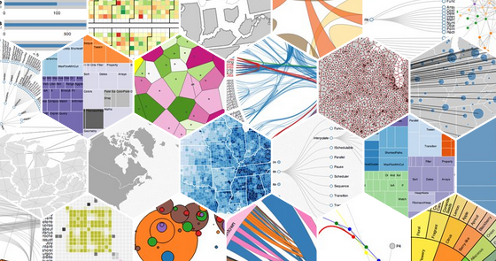

[D3](https://d3js.org/) is arguably the [most popular Javascript library](https://stackshare.io/d3#:~:text=Who%20uses%20D3.,js%3F&text=695%20companies%20reportedly%20use%20D3,Accenture%2C%20Coinbase%2C%20and%20Coursera.) for web-based visualizations in industry. Major newsrooms, consulting groups, and companies all employ D3 as part of their visualization workflows. Given the ubiquity of D3, we’ll spend this week getting hands-on with the library in-class through a series of self-paced activities.

Some administrative notes before we get started:

* In place of standard activities, there will be a series of checkpoint “Test Your Knowledge” activities. Please load your code and/or screenshots into the [Day 1](https://docs.google.com/presentation/d/1tQFrYcFUO1VPvjh1hPZqAY_6n-dWKE0JhlXkQtcoVUw/edit?usp=sharing) or [Day 2](https://docs.google.com/presentation/d/1fN0JTc_P93P5qbtxLLcL0mCa2m3ZXM9FZqNWQwmgI5k/edit?usp=sharing) document to “submit” when instructed. Note that not everyone will complete all of the activities, and that’s ok. I would like everyone to at least get through the scatterplots and expect those of you with prior D3 experience will likely get further.
* As the objective of this module is to explore visualization for the web, we will be developing all of our applications using a traditional web development workflow. You can also experiment with D3 in [Observable](https://observablehq.com/@d3), a web-based notebook platform. The syntax in Observable is a bit different from what we’ll cover here, but the general concepts are more or less the same. I’ve got a [separate Observable tutorial here](https://observablehq.com/d/22d6c6b2a99e46cf) if you want to experiment with this platform as well.
* This is a self-paced activity, but I **strongly** encourage you to work in small groups. I will also be available to support with questions and will cover questions with the whole class when they start to recur or reflect core concepts that I may have missed or aren’t clear in the workshop materials. This is the first iteration of this workshop, but it seems like this class is well-positioned to move at a self-paced rate rather than a live-coding follow-along, so please do ask questions about anything that comes up! (And feel free to leave comments for either myself or your classmates as you go).
* General guidance will be in black while **steps for you to complete independently are in green.**
* One piece of advice: make use of comments (//). If you need to change a line of code, consider commenting that line out rather than deleting it and adding another comment to remind you later what the change means. For example, if I want to change from a linear scale to a logarithmic scale, I might do something like:

// Below I used a linear scale

// var x = d3.scaleLinear().range([0, width])

// Below I used a logarithmic scale

var x = d3.scaleLog().range([0, width])

* Note that the visualizations below aren’t heavily styled: labels and points tend to overlap and the visual design leaves something to be desired. My goal here is to help you learn how to create and refine visualizations in D3, so I’ve left the styling up to you. Feel free to change the style on these vises as you see fit and/or experiment with other ways of doing things.
* I highly recommend finding a plain text editor or IDE for web development that you like. I like Atom, Notepad++, and Sublime Text, but there are tons of others out there.
* Everything there has been tested for Chrome and Brave. Safari and Firefox have some differences in their CSS styling that may cause some bugs in your programs, but I don’t *think* any of the code below should cause problems in these browsers.

**Table of Contents:**

Part 0: Configuration

Part 1: Setting Up Our Webpage

Part 2: Hello, Data!

Part 3: Establishing Scales

Part 4: Adding in Marks

Part 5: Adding More Dimensions

Part 6: Interaction Basics

Part 7: Tooltips

Part 8: Grouping Your Data

Part 9: Building a Bar Chart

Part 10: Building a Line Graph

Part 11: Building a Multiline Graph

Part 12: Building a Parallel Coordinates Plot

References

**Part 0: Configuration**

D3 is a Javascript library, meaning that we’ll be running our code in the browser. Some browsers (e.g., Firefox) have specialized tags that can require minor adjustments for our code, but I don’t believe that any of the materials in this tutorial should be subject to that limitation.

For this activity, we’ll be loading in datasets from an external document (a CSV in this case). Given the way browser security works (the tl;dr, it won’t let random websites read files from your computer), you’ll need to set up a server. If you have access to a webserver already, you’re welcome to use that, but you can also just set something up locally. We’ll walk through the local option here.

Create a folder where you want to put your data and code. For simplicity’s sake, we’ll keep everything in this folder, though you could use other structures or even grab data live from the web. Once you’ve created this folder, download the dataset [here](https://drive.google.com/file/d/1Q7YsOSxPmgHCrffUSIcO6Q55-YbNildK/view?usp=sharing) and put it in the folder. Then, you’ll pull down the skeleton code [here](https://drive.google.com/file/d/1ug8LroD6OaEixpSRLxeL6kdICNoiiBA9/view?usp=sharing) to get started.

The last piece is to get your webserver started. From the command line, you’ll want to navigate to the folder you’ve created. Then run the python command shown below:

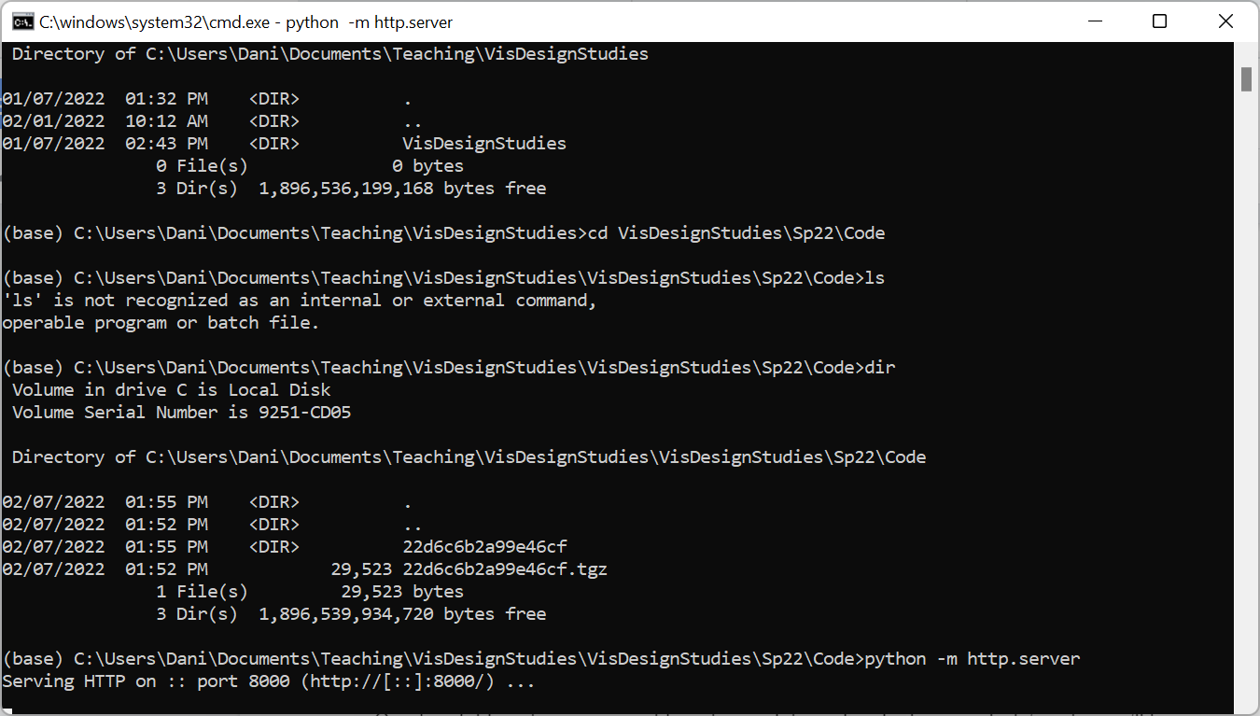

If your command is successful, you should see something like the output below:



What this means is that there is now a simulated webserver running on port 8000. If everything is configured correctly, you should be able to go to localhost:8000 on your browser and see a listing of files in the folder you’ve created. Now you’re read to start using D3!

**Part 1: Setting Up Our Webpage**

Open the d3-tutorial.html file in a plain text editor (e.g., Atom, Brackets, Sublime Text, Notepad++; Word or another rich text editor won’t work, but most major IDEs will be just fine if you prefer that route). You’ll use this editor to build out your code. Note that if you have a tool you like to do web development in, that should work just fine (we’re not doing anything special in terms of HTML or Javascript that requires more complicated functionality).

We’ll first want to import D3 into your visualization. We can do that by directly importing the appropriate D3 version from the web (you can download your own stable copy if you’d prefer). While D3 v7 is the most recent version, it is also in active development. We’ll use v6 (the most recent stable version) for this tutorial. You can view or import the D3 javascript file from <https://d3js.org/d3.v6.js>. To import the library into your own visualizations, simply use the following HTML command:

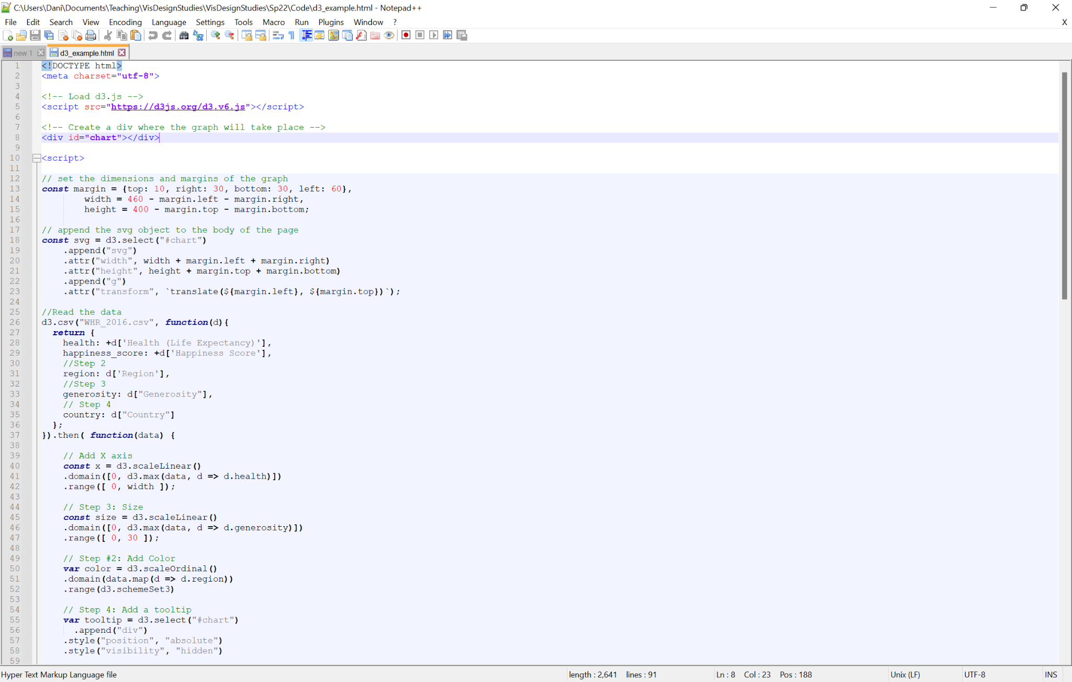

Note that the <!--...--> structure indicates an HTML comment. The <script> tag imports a Javascript document from the URL specified in src. At this point, syou may wish to save the file and refresh localhost:8000 in your browser. Click on the name of the file or go to localhost:8000/d3-tutorial.html to view the page. You should see a blank page, but if you open up the debugger (if you’re in Chrome, open the settings menu to the right of the address bar in your browser, go to More Tools, then choose Developer Tools, above left), you can verify that there were no issues importing the library by checking that no errors appear in the Console (see above right). 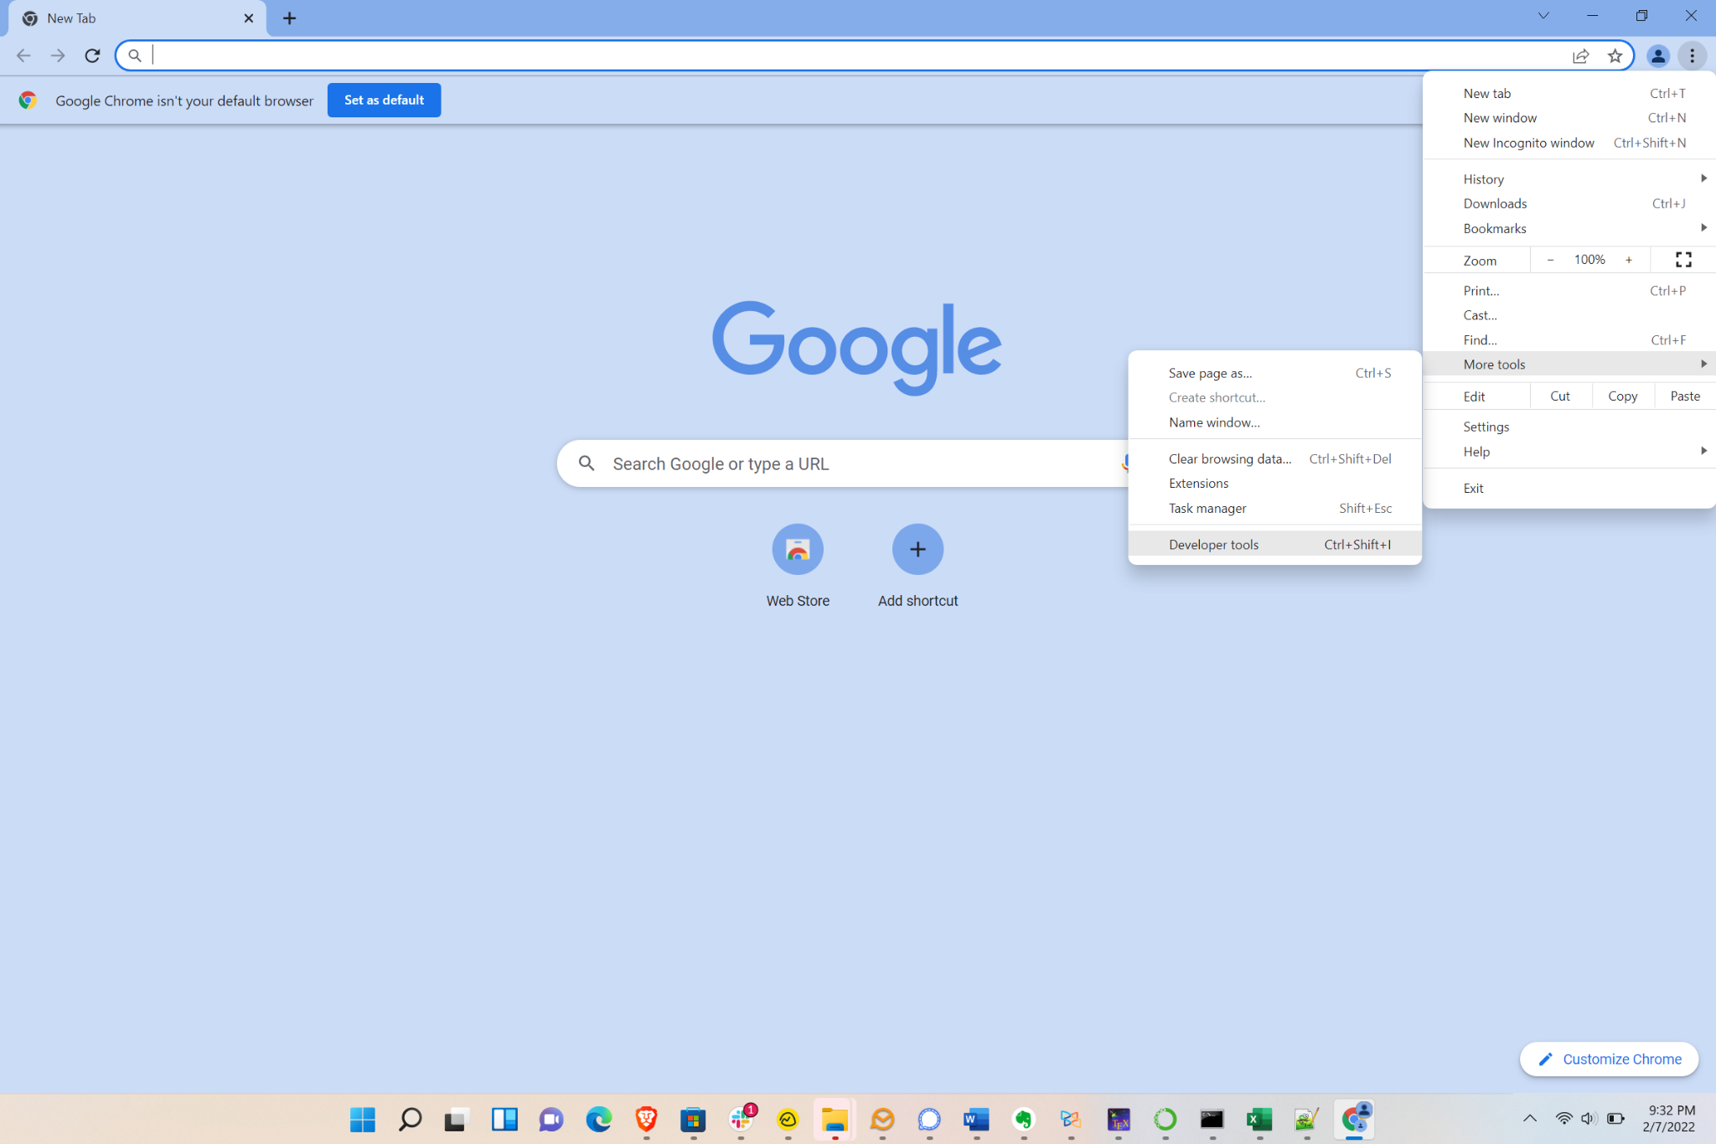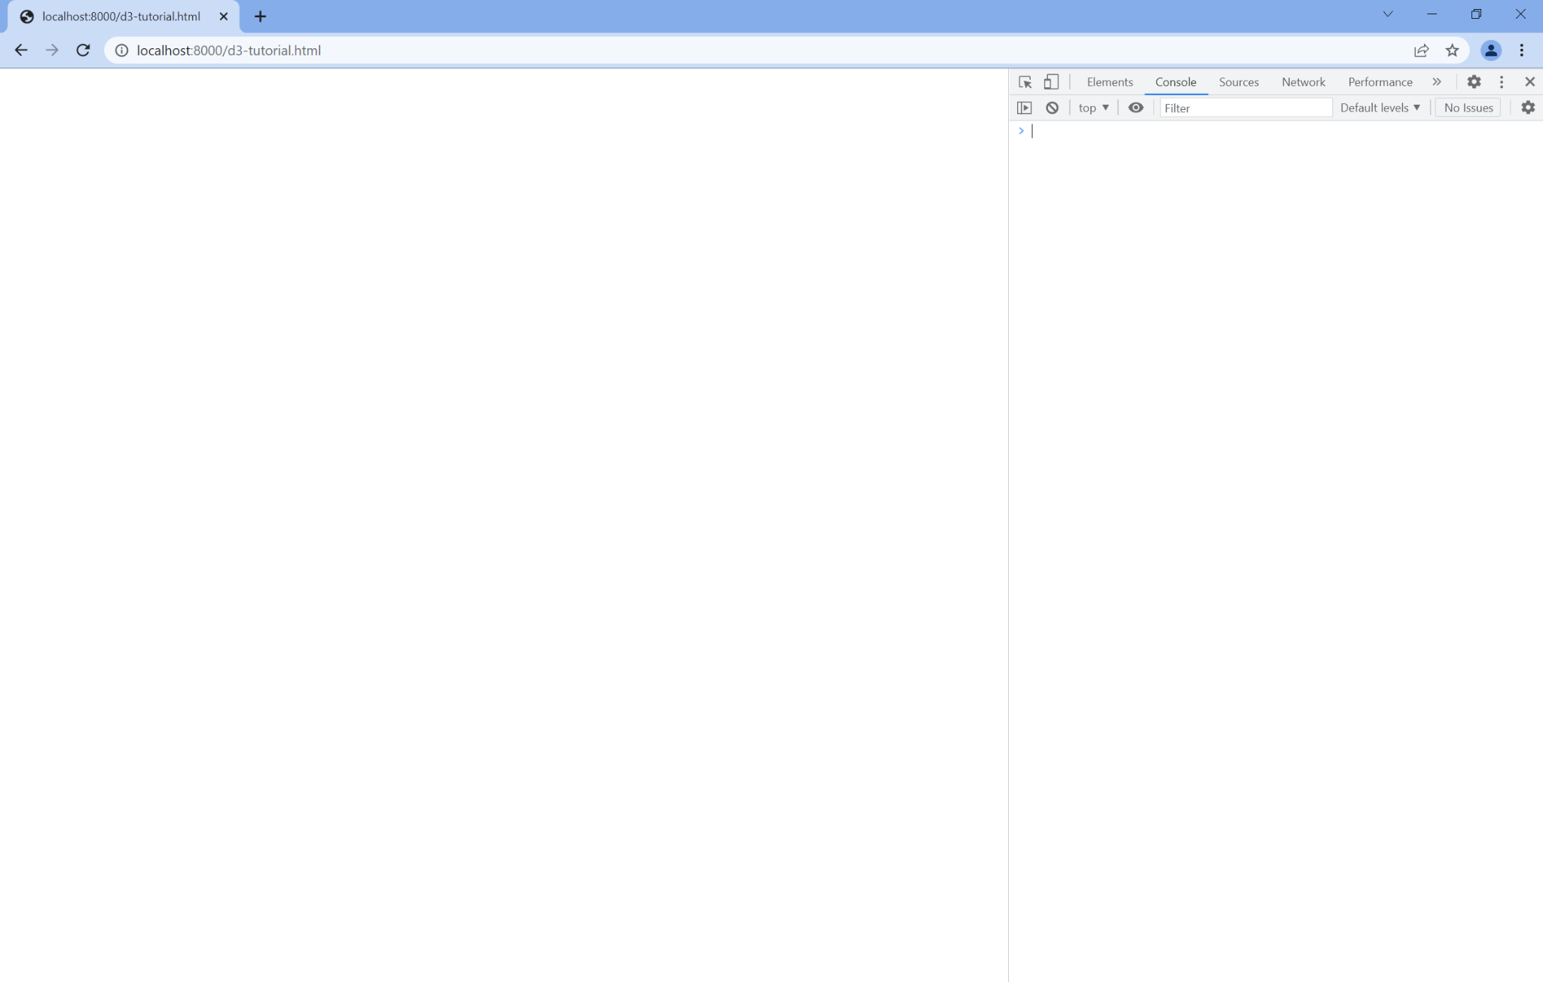

Next, we’ll add an HTML [div](https://www.w3schools.com/tags/tag_div.ASP) to hold our visualization. You can do that by adding the following HTML code below your import statement:

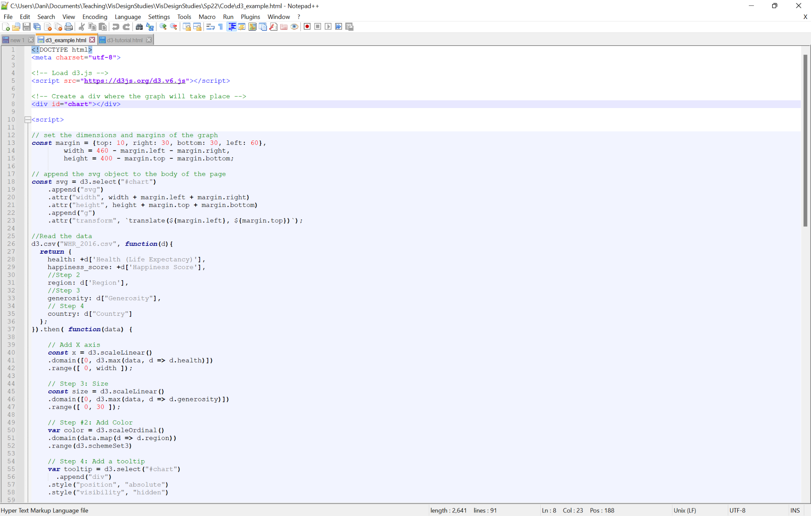

You can replace chart with any identifier you’d like, but I recommend keeping it simple as we’ll grab a reference to that object in our code. We can now add a script block ( with several blank lines in between) after our div to hold our Javascript code. All of the rest of the code for this tutorial will be in between <script> and </script>, To get started, we’ll create two things: a variable to hold the parameters of our visualization (e.g., its height and width) as well as an SVG canvas that will hold our visualization.

To specify the parameters of the visualization, we’ll create a series of constants that enumerate pixel values for our visualization. We’ll first create a Javascript object called margin that has properties top, right, bottom, and left. This will give us a set of numbers that correspond to the pixel padding we give to our visualization accessible using dot notation (e.g., margin.top). We want to set up that padding so we’re not losing data off the edge of our canvas. We’ll also specify a width and a height. The code below reflects the constants we want to use to create an 800 x 600 visualization with a 50 pixel margin for rendering any additional material (e.g., axis labels).

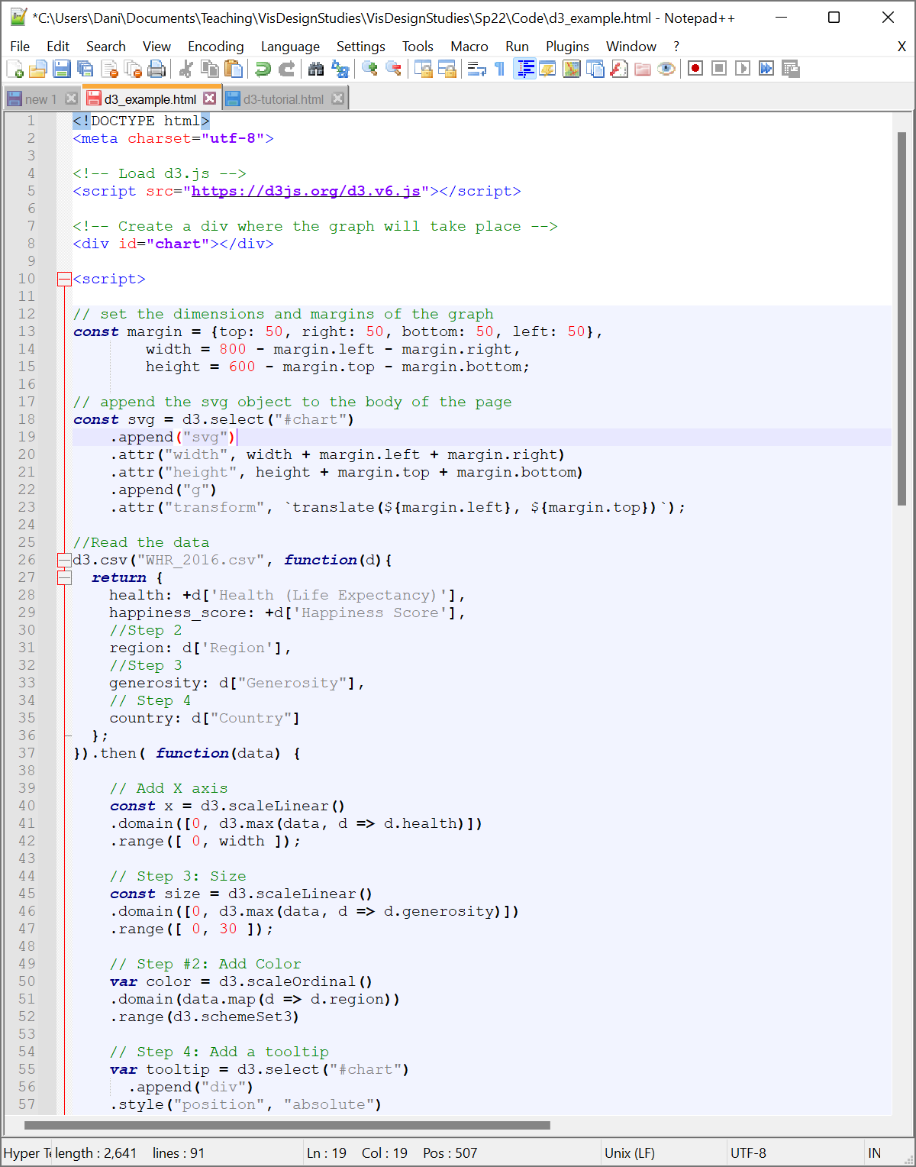

Note that I’ve divided out my variable declarations using commas and closed the declarations with a semicolon. Two quirks about Javascript: 1) you don’t have to end lines with semicolons (there are times where it’s not so optional, but we won’t worry about those for now) and 2) you can separate out each constant with its own new line and const declaration OR just use a comma.

Next, we’ll create the SVG canvas that will hold the visualization. To do this, we’ll want to append an SVG element to the chart div we created earlier. This chart will have a height and width corresponding to the parameters we just specified with our constants.

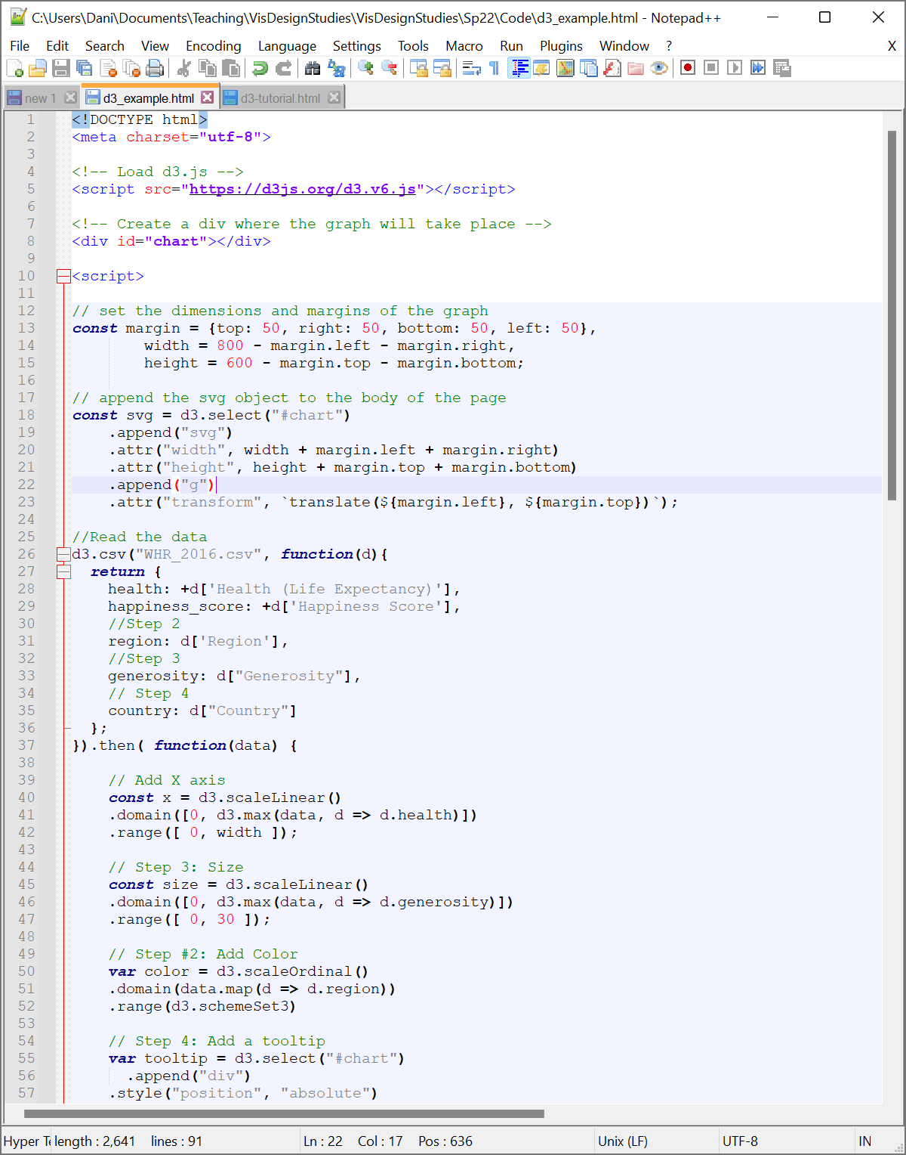

In the code above, we’ve grabbed the div element chart (d3.select(“#chart”)) and added a new SVG object to it (append(“svg”)). Once we’ve created this new element, we can specify its size by setting its *attributes* (properties of the SVG object) “width” and “height”. In D3, we do this by first specifying that we’re working with an attribute using the attr function, then specifying the specific attribute we want to set using a string (“width”), and finally setting that attribute to some value (width +margin.left + margin.right).

The margin math above is going to make our graphs appear nicer by giving them a buffer from the edge of the screen and giving us some additional room to work with. However, it’s a pain to constantly be worrying about doing the math with these margins. To make our lives easier, we’ll shift our origin in the canvas from the top-left (the default in graphics) in margin.left pixels and down margin.right pixels using a *group* (g). We’ll do this by adding the group to our SVG and then applying a *transform* that *translates* (moves) the current origin to our desired coordinates. The full code looks like this (note the specialized quotations in the translation that lets us specify Javascript variables inline in the string):



If you save your file and refresh your webpage, you can click on the Elements tab of your debugger and see the div and no error messages in the Console.

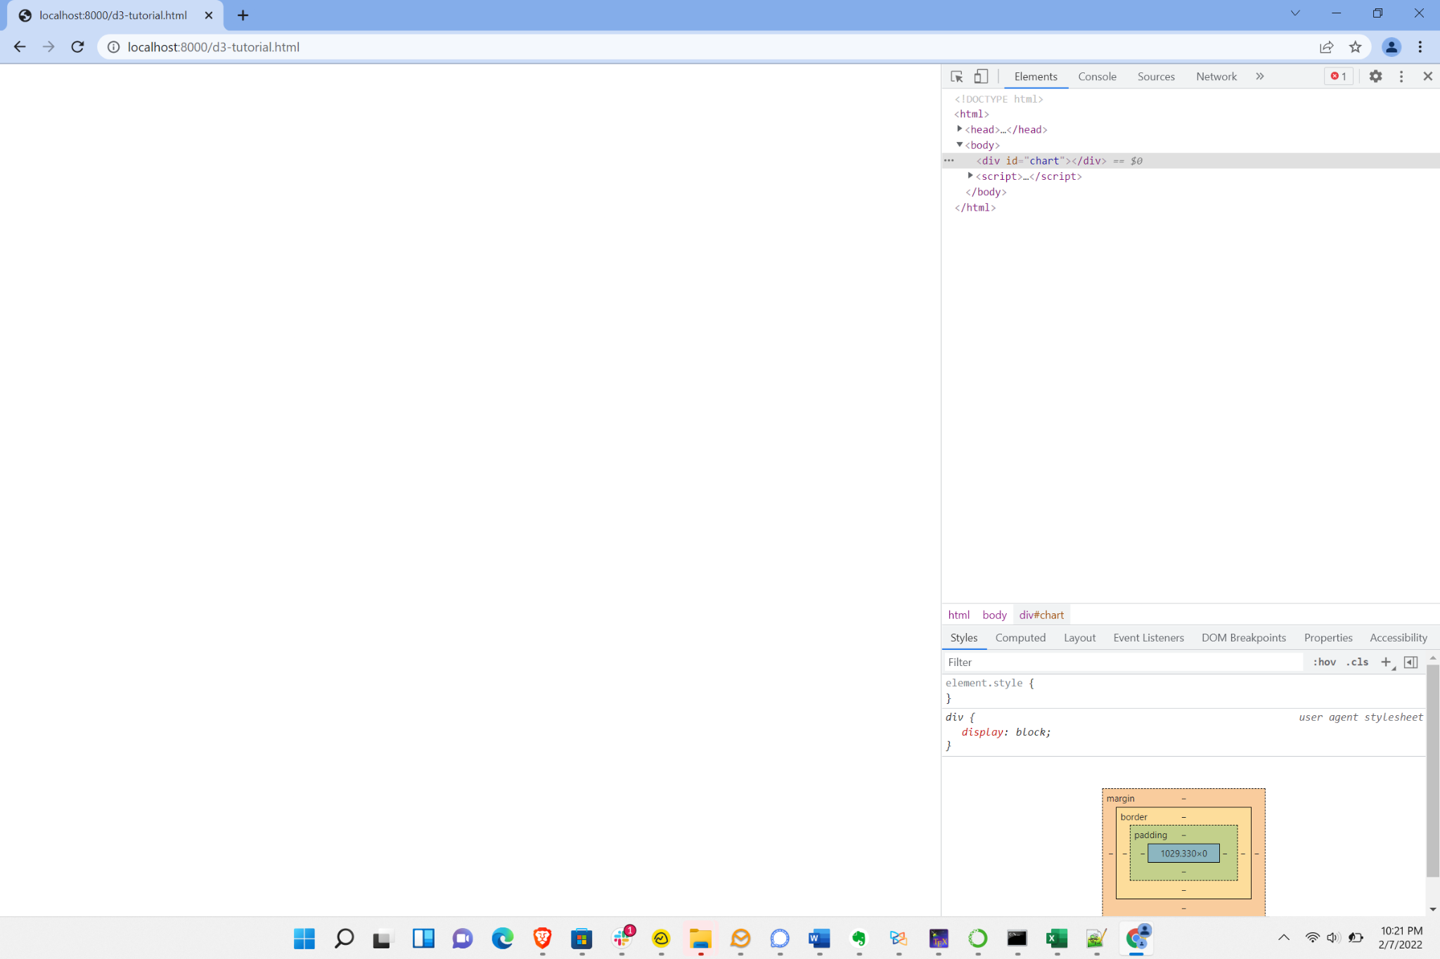

**Part 2: Hello, Data!**

D3 provides functionality to load in data from a range of data sources. For the purposes of this activity, we’ll load from CSV (comma-separated values). Th is is basically an old fashioned table with commas separating each column and (typically) one row per line. You can use any text editor (e.g., Atom, Brackets, Sublime Text, Notepad++) or spreadsheet tools like Excel to view and edit CSV files. Feel free to open the file up and take a peek or look at the data description available at <https://corgis-edu.github.io/corgis/csv/global_development/>.

The data we’re working with today is a dataset of World Bank Economic Indicators collected over time. The data has been filtered to select for data samples on each decade to keep the volume more manageable: 756 total datapoints. You’ll find that due to the way that D3 relies on scalable vector graphics [SVG] to render data, things get really slow over ~5,000 datapoints and you’d need to pivot to either hybrid or fully rasterized solutions to get quality interactive performance.

Within your script block after you add your SVG, you’ll add the code to import this data. While there are a number of columns in the dataset, we’ll only focus on importing those we plan to use. We’ll use the d3.csv function to import our data. This function will initialize a callback: within the function, you’ll specify what data to process and how; after the function, you’ll use the then function to specify what happens after all of our data is loaded.

d3.csv takes two arguments: a string filename and a function that tells D3 how to process each line of that file. Typically, your function will take each row in your CSV (d, short for datapoint, in most cases) and return a Javascript object where each property of the object maps to one column in your dataset. For example, if we want to pull in the Country, Birth Rate, and Death Rate values in our dataset, our code would look like this:

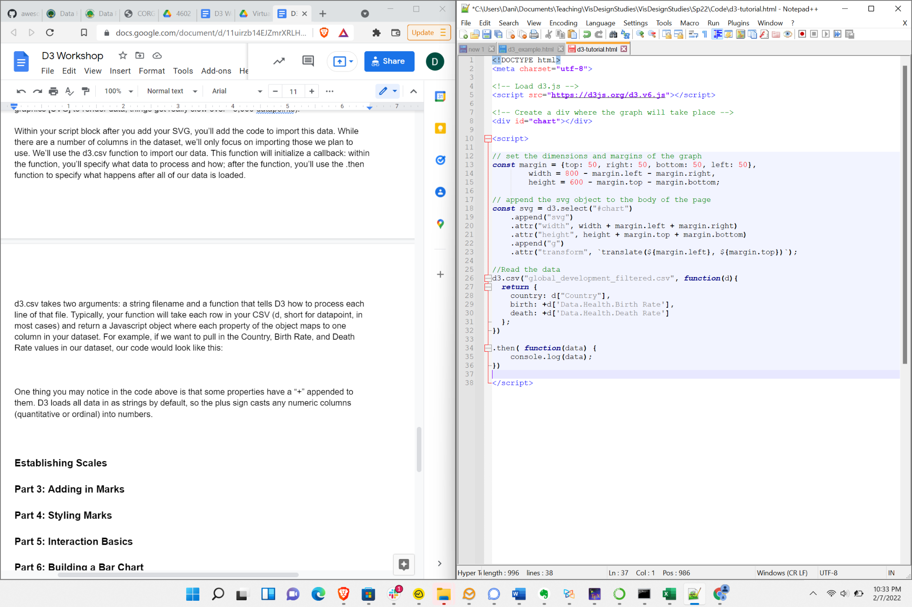

One thing you may notice in the code above is that some properties have a + appended to them. D3 loads all data in as strings by default, so the plus sign casts any numeric columns (quantitative or ordinal) into numbers.

The next thing we want to do is specify what we do with these data values once they’re parsed. We do this using the then function appended immediately onto our d3.csv call. For now, let’s just print out the data to the Console to verify that our data parsed correctly. We’ll do that using console.log. The full code looks like:

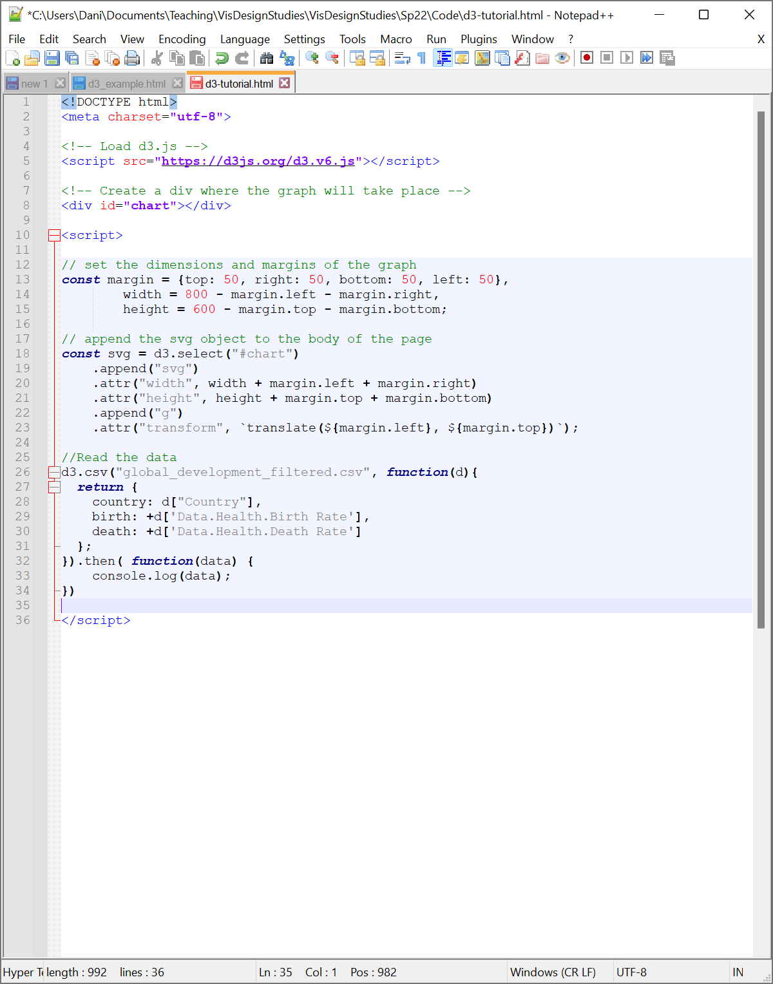

You can check your work by saving and refreshing. In the Console, you should now see the data array parsed from the CSV file. You can use the dropdown arrows to unpack the array and look at individual data objects.

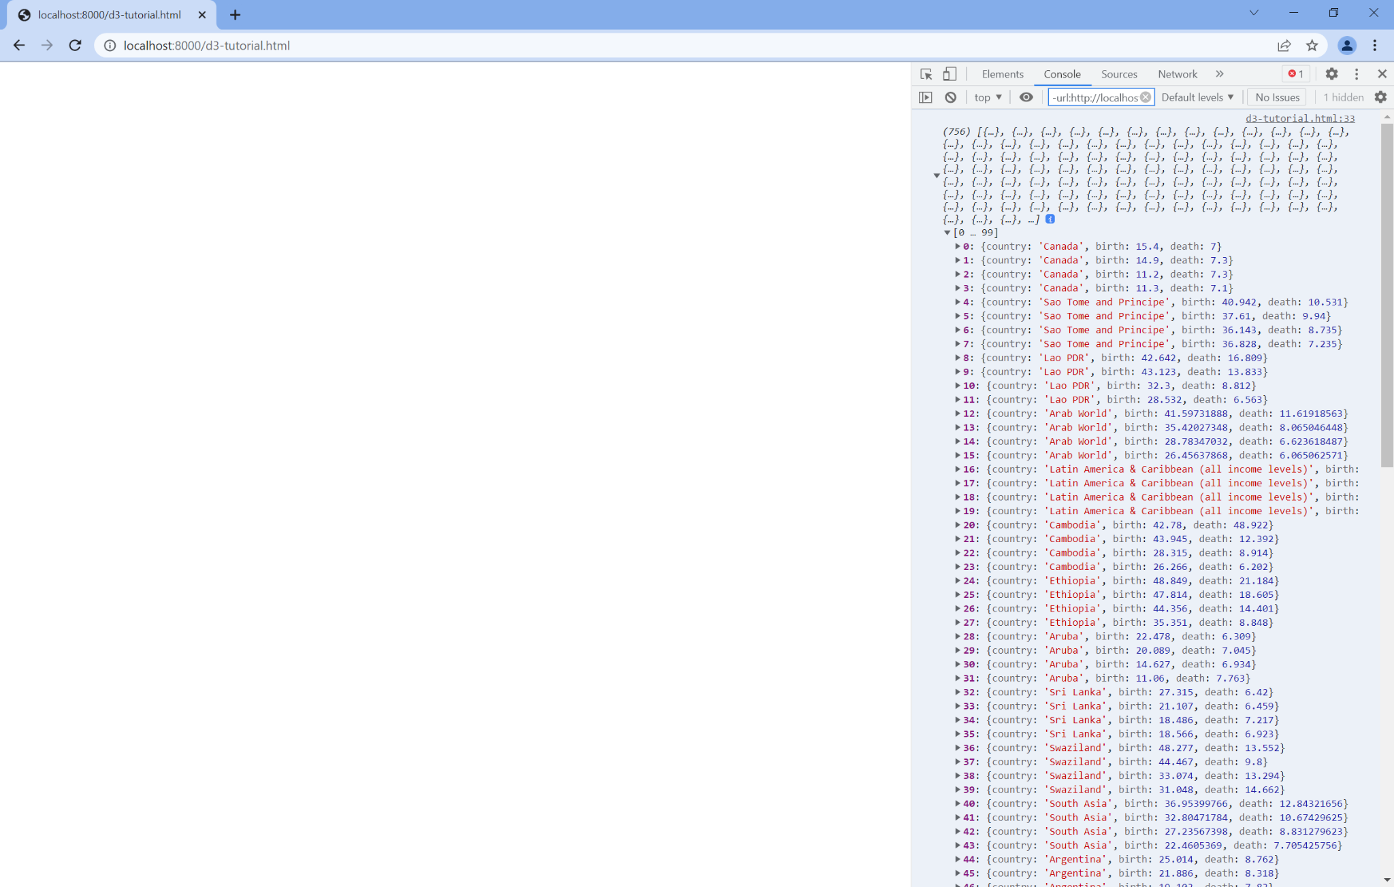

**Part 3: Establishing Scales**

We now have a totally functional (if also totally boring) D3 program running in the browser. Let’s turn this into something *slightly* more exciting: a scatterplot. To start building out our visualization, we’ll return to our Grammar of Graphics and the idea of scales.

Our scales will determine the mapping between data space and pixel space (or, more generally, visual space as we’ll see later). Scales in D3 have two key properties: a domain and a range. Note that in traditional mathematics, we think of the domain as the span of x-values and the range as the span of y-values. Things are a little different in this case: a scale is more like a traditional function. Your domain refers to the range of possible data values and your range refers to the range of possible pixel values. In this case, you’ll provide these by giving a two-element array [min value, max value]. We can specify the type of map(ping between these two sets of values by specifying the kind of scales we wish to use.

Since we’re starting with a simple scatterplot, let’s just specify a pair of linear mappings for our x- and y-positions (though you can explore other scale types [here](https://www.d3indepth.com/scales/)). We’ll want to start these axes at 0 to avoid potentially misleading people about patterns in the data (you can read more about this choice [here](https://interactions.acm.org/archive/view/july-august-2018/the-good-the-bad-and-the-biased) if you’d like a high-level discussion of why). To create each axis, we’ll use d3.scaleLinear, which will return a linear function that transforms a data value to a pixel value. You’ll want to store that scale to use later both to map our data as we build out our graph and to render our axes on our final visualizations. We can start constructing these axes by adding the following code inside of our then function (immediately after our console.log statement is as good a place as any):

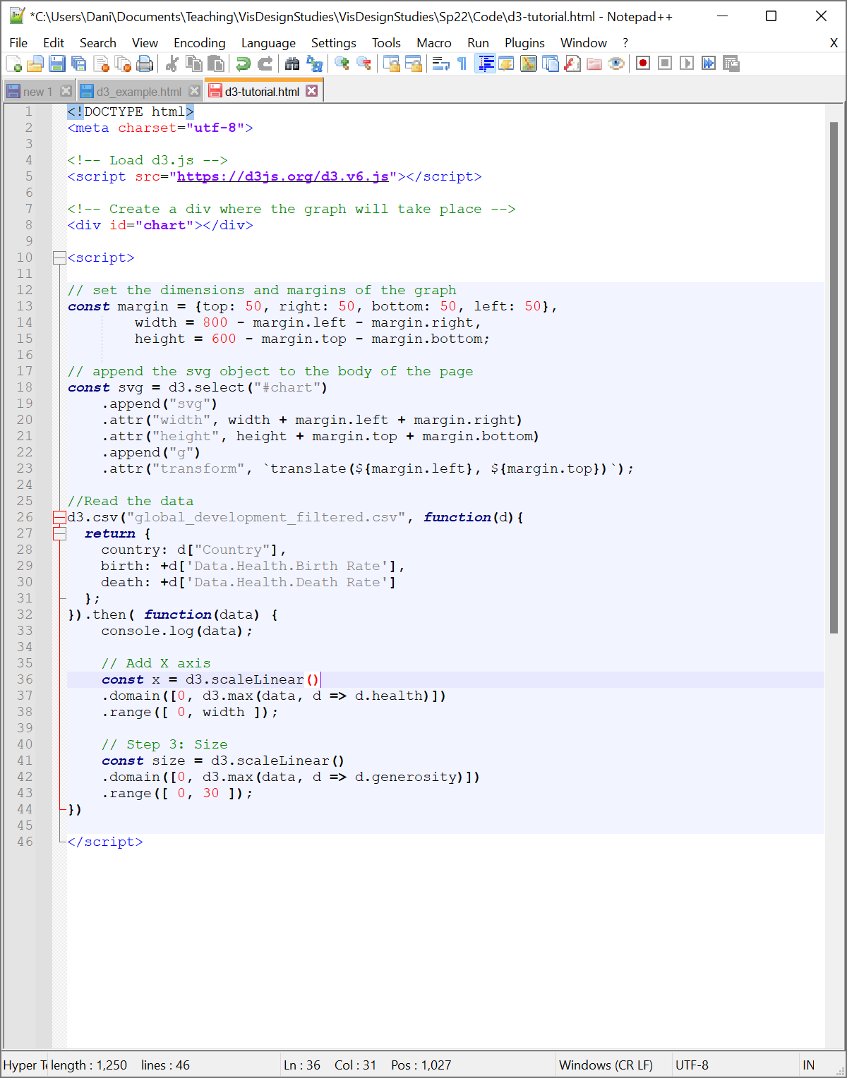

Once we’ve created our axes, we need to specify our domain and range. We can let D3 help us parse out our data by pulling out the highest birth rate value using the d3.max function. This function takes in a data array and a function specifying the data element to find the maximum of. We can shorthand this function in D3 using d => d.birth, which will grab the birth property of each datapoint d. We can then specify the pixel range we want to map this data to. In this case, let’s use the extent of our graph: 0 to width. The finished code looks like:

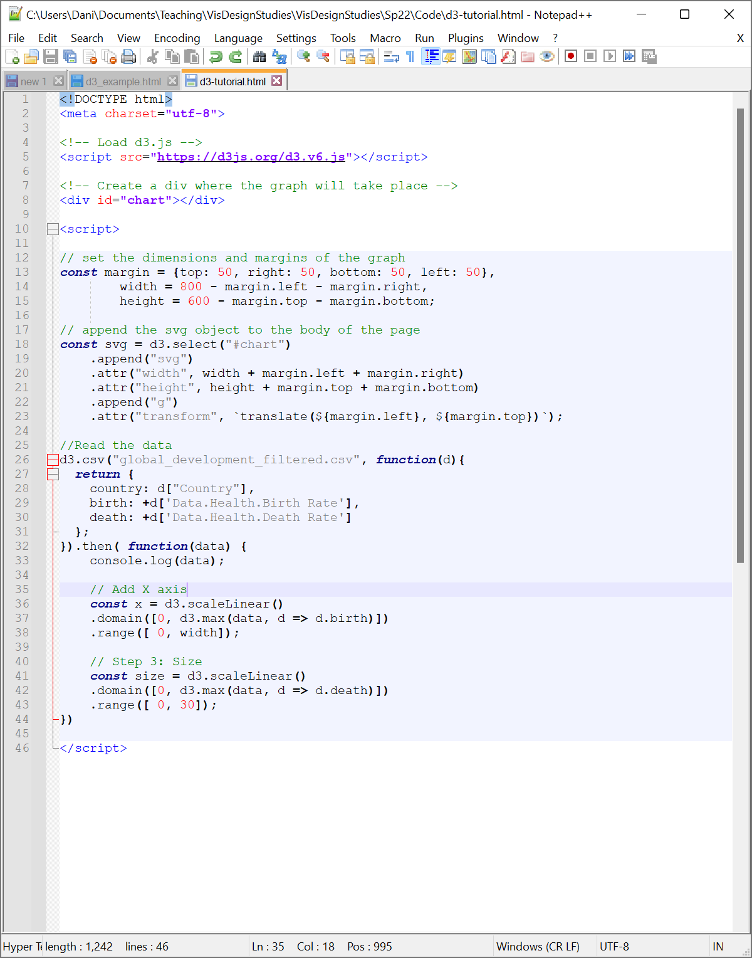

**Test Your Knowledge: Create a y-axis scale y that maps the death rate of each datapoint. Keep in mind that the origin of the graph is in the upper left (not the lower left as in a traditional Cartesian plot).**

Now that we’ve created two scales, we can add the corresponding axes to our plots. Axes are sufficiently common in D3 that we just have to 1) append them to our SVG, move our drawing origin to the right spot, and 3) call a function to draw the axes. For the first step, we can use the SVG we created in Part 2. We then add a group g to translate to the upper left of the axis (in the case of our x-axis, the bottom left corner of the graph). Finally, we use the call function to call the appropriate D3 axis function. These functions are named after the location of the axis (e.g., d3.axisBottom or d3.axisLeft) and take our scale as their argument. After that, D3 handles all the formatting and rendering for us.

As an example, we can draw out the x-axis by translating to the bottom-left of the graph and calling axisBottom with x as our argument. The code looks like this (following right after our scale declarations):

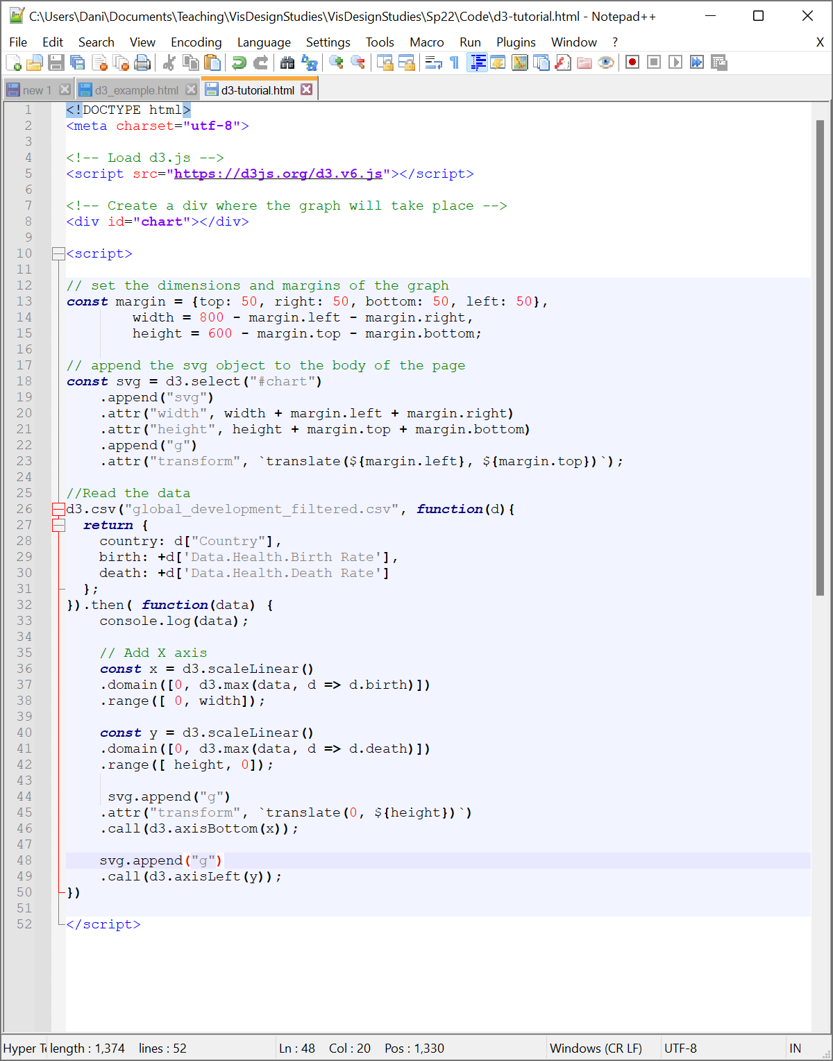

If you save and refresh, you should see a single x-axis on your screen labeled from 0 to 55.

**Test Your Knowledge: Add the y-axis to your visualization. Note that you’re already in the upper left corner of the graph, so no need to translate your drawing origin.**

**Part 4: Adding in Marks**

You now have a pair of empty axes and not much else. We’ll shift our focus to adding in our marks. We can do this by selecting data using a class name (in this case, dot), binding that selection to our dataset, and creating a series of SVG objects for each element in the dataset.

Stepping through this process, you’ll start by appending a new group to your SVG. Once that’s set, you’ll want to select all elements of your specified mark class. In this case, we’ll call that class dot (since these are scatterplot ‘dots’), though you can use nearly any other name if you’d like. We’ll use the selectAll function to grab a pointer to any existing dot objects by passing the string “dot” as your argument to the selection. Note that while there are no such objects in the current visualization, selecting all objects will let you create new marks if they don’t exist or will grab an array of existing dot objects if any do exist (this comes in handy if you’re looking to update your visualization through interactions, as we’ll see later on).

We then bind each of the selected objects to our data using the data function. Data will simply take in our dataset data as an argument (you’ll recall we passed this in as our sole input to the then function in Part 2). This will create a mapping from our dot objects to our datapoints, creating new dot objects for each datapoint that doesn’t already have one (in other words, the number of dot objects == the number of datapoints). We can then create an SVG circle for each of these dot objects using the join function. The general syntax looks like:

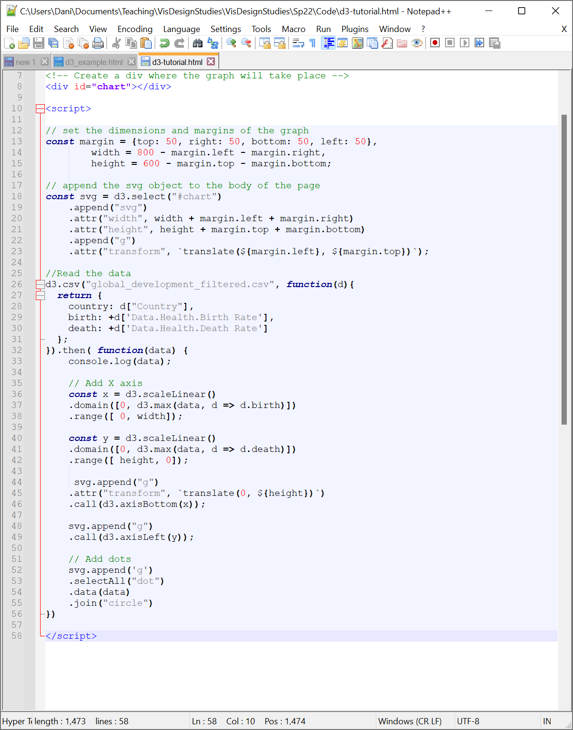

We can check our work in the Elements window in our debugger. We should see an SVG that, when you drop down the list of elements within it, has three groups of objects. If you expand the third group, you’ll see a whole lot of circles (though they won’t show up on your graph quite yet).

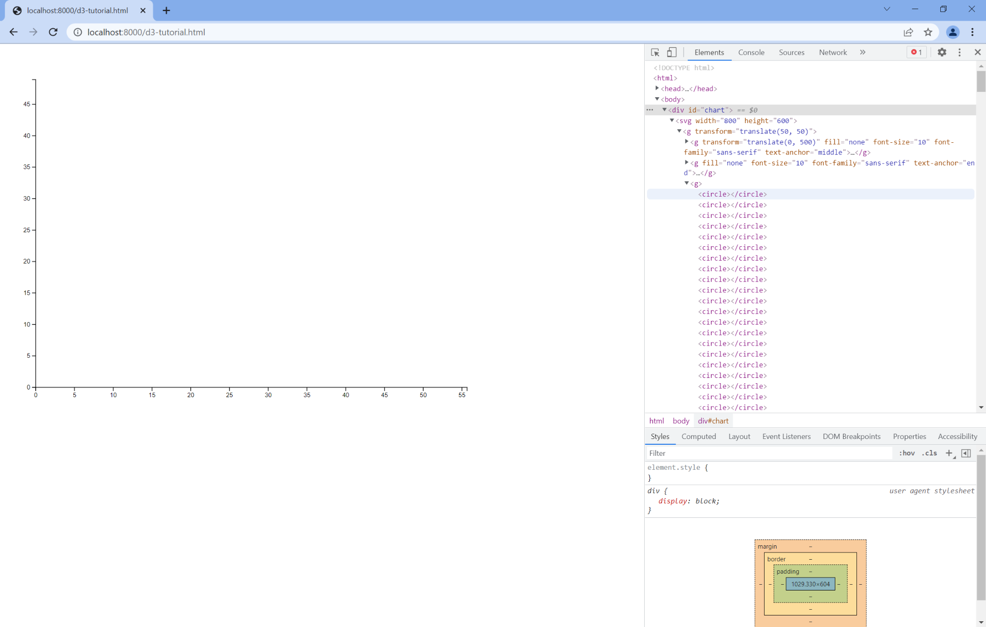

Each of these circles is an SVG circle, which means they have specific properties that we can set using D3. For now, we’ll focus on three of these: r (radius), cx (x-position), and cy (y-position). We can add these properties by appending more functions onto our join function (anything after this function gets appended to all of the selected elements—in this case, all of our scatterplot points). Starting simple, we’ll render each scatterplot point with a 5 pixel radius. We can do this using the same attr function we used in Part 1. The code looks like this:

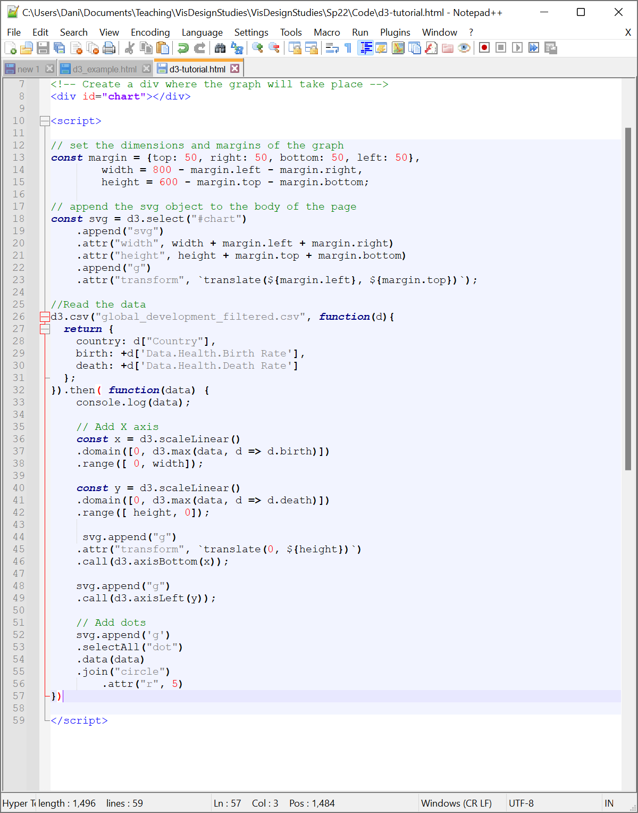

If you save and refresh, you should see a tiny scatterplot point in the upper left corner of your scatterplot. It turns out, this is several hundred points drawn on top of one another! To fix this, we can start by specifying the x-position. To specify the cx attribute, we’ll need to set the attribute value using a function rather than a fixed number. We can set our cx value to a function that simply returns the birth rate value for a given datapoint, transformed to pixel space by our x scale from Part 3. To do this, we swap the second argument in our attr function with a function that takes an argument d (short for datapoint). The function returns the output of the birth rate value of that datapoint passed into our x scale. In other words:

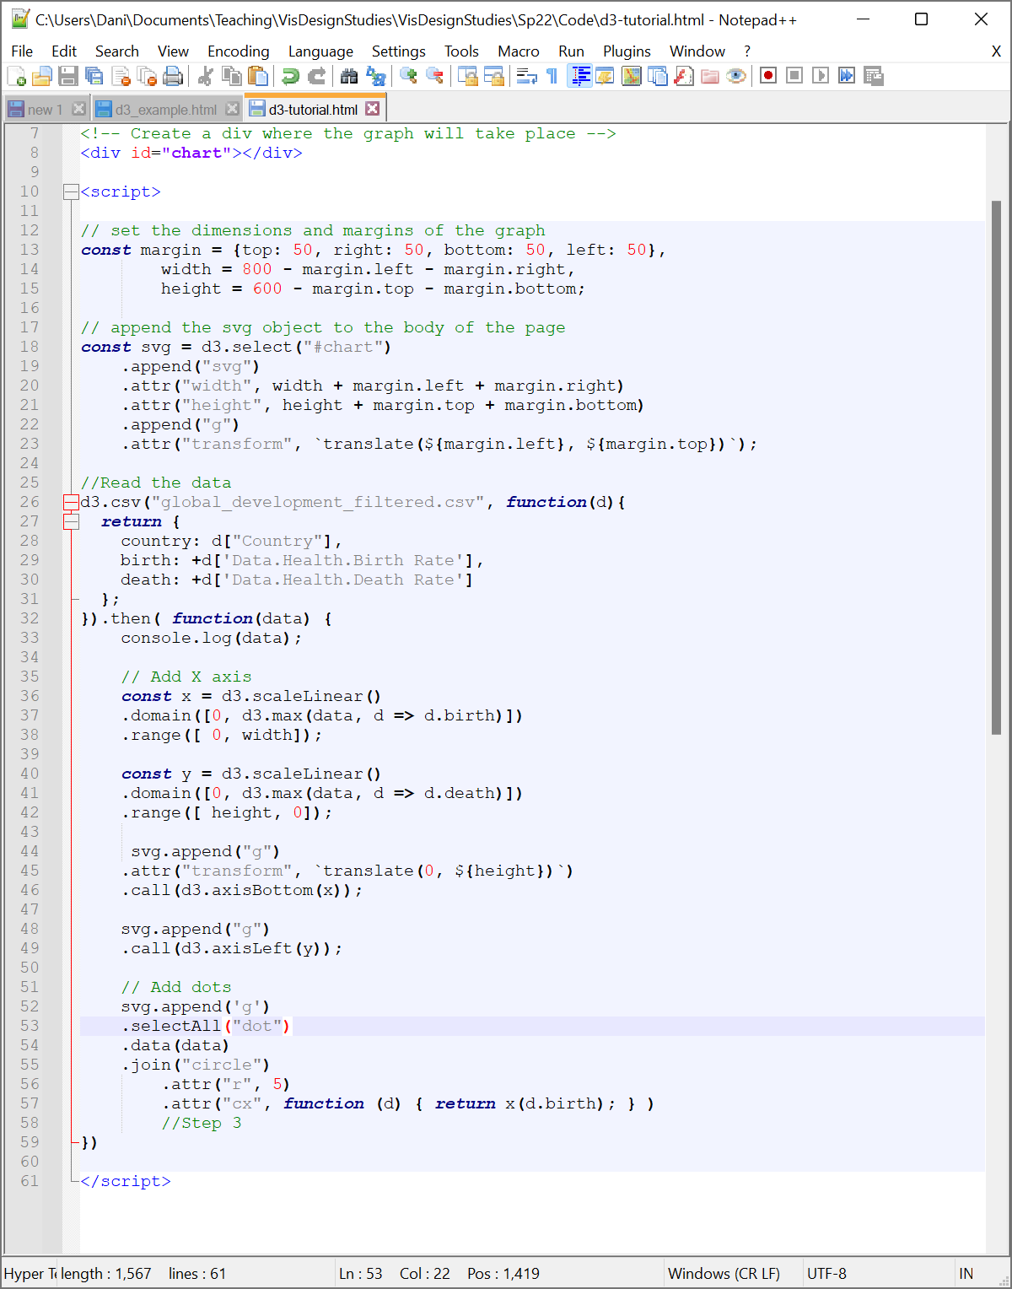

If you save and refresh, you should now see a line of datapoints at the top of your graph.

**Test Your Knowledge: Set the y-position of your points to the death rate. Your graph should look like the graph below.**

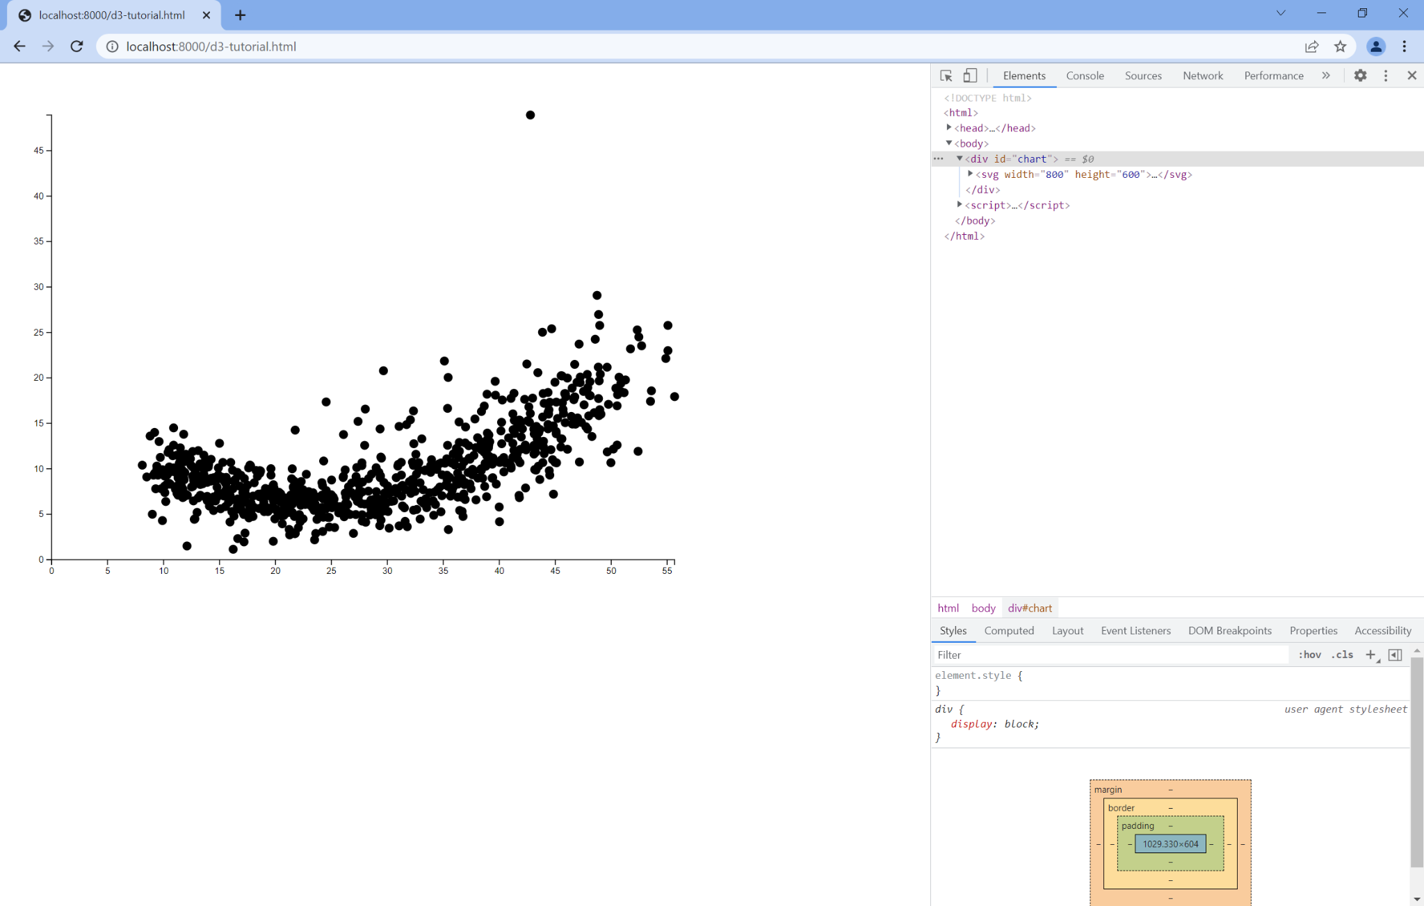

**Part 5: Adding More Dimensions**

We can manipulate the CSS (cascading style sheets) style of the points in the graph using the style function. This function behaves exactly the same way as the attr function, but controls a slightly different set of values. For example, we can use the style function to set the fill color of our points to a light blue.

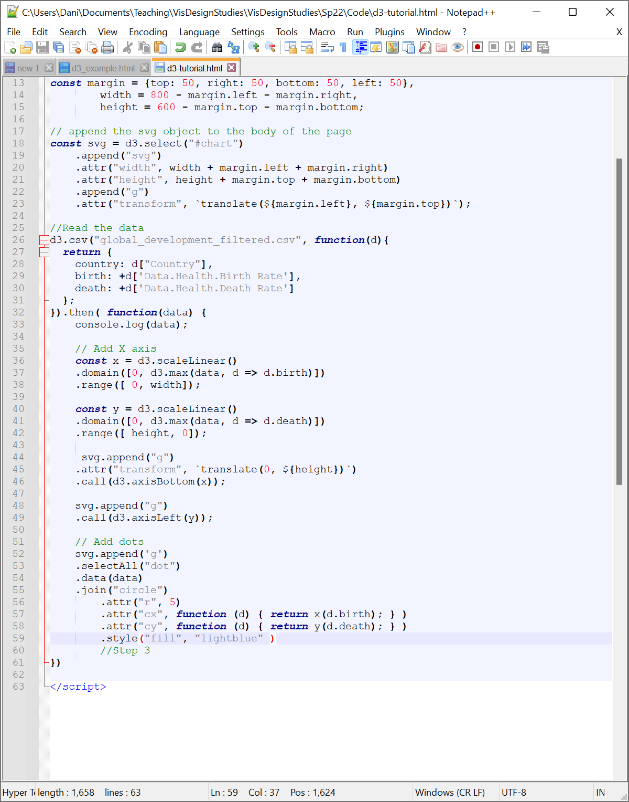

We can also create new scales to integrate additional dimensions into our visualizations through attributes and styles. Let’s start by mapping color to the total population of each datapoint (Data.Health.Total Population).

**Test Your Knowledge: Update your data loading code from Part 2 to add a new property to the data called population that maps to the Data.Health.Total Population column in the dataset.**

We can then create a scale mapping the new population property to color. In this case, since population is a number, we’ll map it to a continuous sequential colorscale (in other words, the colors appear to change in a continuous sequence, going from light to dark). For the purposes of this example, we’ll use Viridis, a popular colorscale from MatLab, but D3 has a number of other colorscales and will let you even specify your own custom choices by specifying an array of colors to interpolate between.

To create the scale, we’ll use a similar syntax to our position scales. Two primary changes here: since colors interpolate in a three dimensional space, we’ll use the scaleSequential (rather than scaleLinear function and we’ll change the range to an interpolator, which will interpolate between the range of colors specified in Viridis rather than a range of numbers. Create this scale before your mark code (right after your y-axis code is a good spot). In this case, we’ll shift our scale slightly to match the *extent* of the population values (i.e., the min and max values) rather than starting from 0. Your scale will look like:

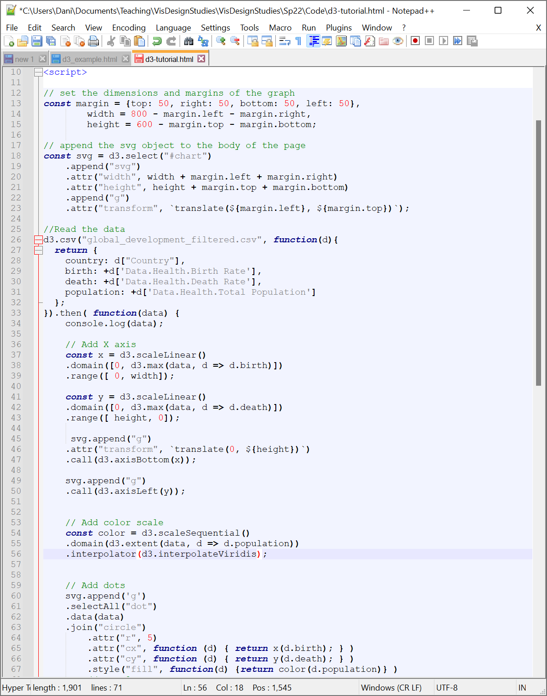

**Test Your Knowledge: Update your fill style to use the new color scale.**

At this point, you might notice that there are still a lot of points drawn on top of one another. To fix this, let’s just reduce the opacity of our points to .5 (0 is transparent, 1 is fully opaque). We can do this by adding another style function and mapping it to opacity.

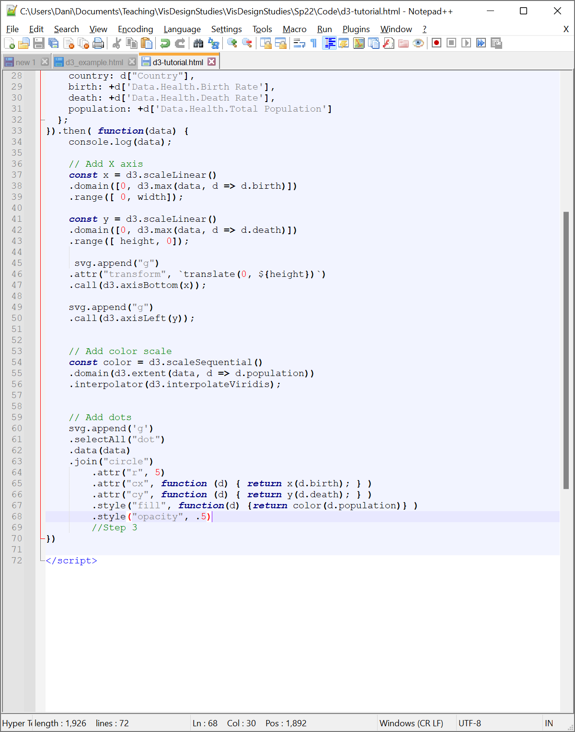

While this doesn’t fully solve the problem (and there are lots of [other approaches](https://alper.datav.is/publications/scatterplots/) to handling this issue of overdraw in scatterplots), you can start to see where the most dense clusters of points lie.

**Test Your Knowledge: Choose another dimension of the dataset you might be interested in exploring. Parse that dimension and map it to size to create a bubble chart. Post a screenshot of your visualization and a note indicating which dimension is mapped to size.**

**Part 6: Interaction Basics**

One thing we might want to do at this point is let the user filter for certain categories of data. For example, if I click on a scatterplot point, I may only care about seeing points that represent the same country as the point I’m selecting. We can use D3’s on function to manage interaction. on takes a string specifying the type of event (e.g., “click”) that serves as input to the interaction and a function that defines how the visualization responds to the interaction. In this case, we might create a function that takes in two elements—the event type e and data type d—and shifts the opacity of all circles based on whether or not they represent the same country.

To do this, let’s start simple: let’s just print out the country data to our Console. We’ll set up our on function and just tell the function to log the country of d to the Console as follows (note the closing bracket and parentheses to help with next steps):

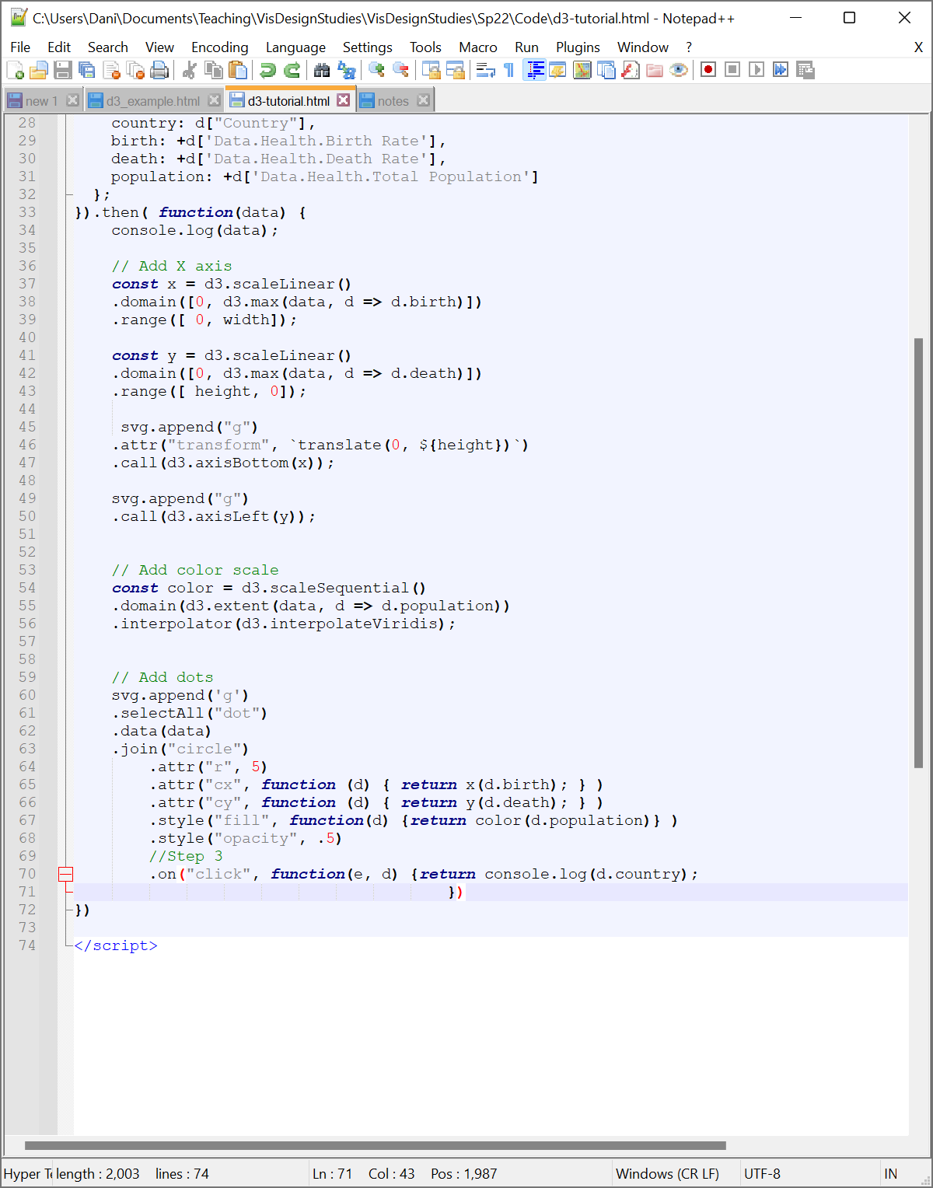

From here, we can set up our logic to change the visualization’s opacity. We’ll start by selecting all of our circle elements. Then, for each element, we’ll set the opacity to 1 if the element has the same country as d and 0.1 if the element does not. Our resulting code looks something like this:

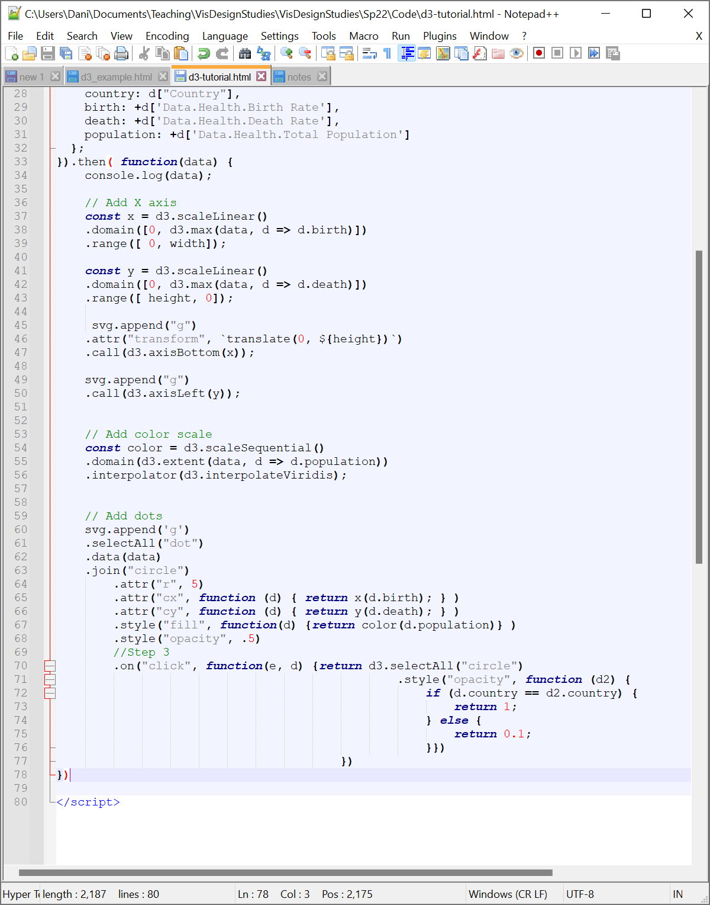

**Test Your Knowledge: Change your visualization to instead adjust the size of the scatterplot point instead of its oppacity if the corresponding country is clicked.**

**Part 7: Tooltips**

We may wish to understand the specific data more precisely than an encoding can support. To do this, we’ll create a tooltip in our scatterplot. We can do this by adding new div elements to the visualizations to hold some text and change their position, text, and visibility based on where our mouse is at in the visualization.

Since we want to be able to show the tooltip when we interact with the marks, we want to make sure it exists before we specify the on behavior of our marks. To do this, we’ll put the code to create the tooltip after we draw our x and y axes.

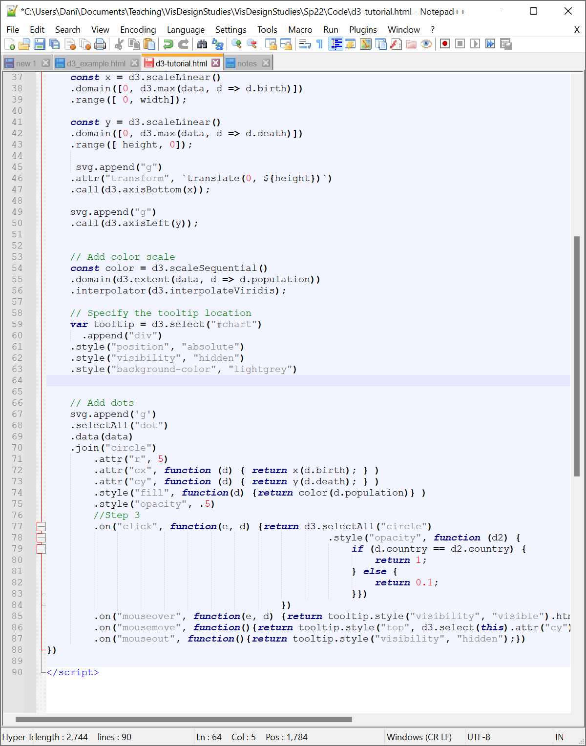

This code adds a new div element to the webpage we’re drawing our visualization in. We also specify that the position should be absolute (i.e., it should draw exactly where we tell it to—that will be important given you want the tooltip to appear on the appropriate mark). We also start the tooltip off as being hidden: we can’t see it until we need it. Finally, we set the background color of the tooltip to light grey so that we can actually read the text in the tip (feel free to turn that off later or adjust the color to see why this is important).

We’re now going to specify three events that will trigger the tooltip: mouseover, mousemove, and mouseout. Let’s start with the mouseover code: we want the tooltip to have some text and to be visible (not fully transparent) when we mouse over a point so that we can see the text. To do that, we first will set the visibility CSS attribute to “visible” and specify the text in HTML as a string. You can use standard HTML formatting to concatenate a string with lots of details, but for the sake of simplicity, we’ll just output the country name.

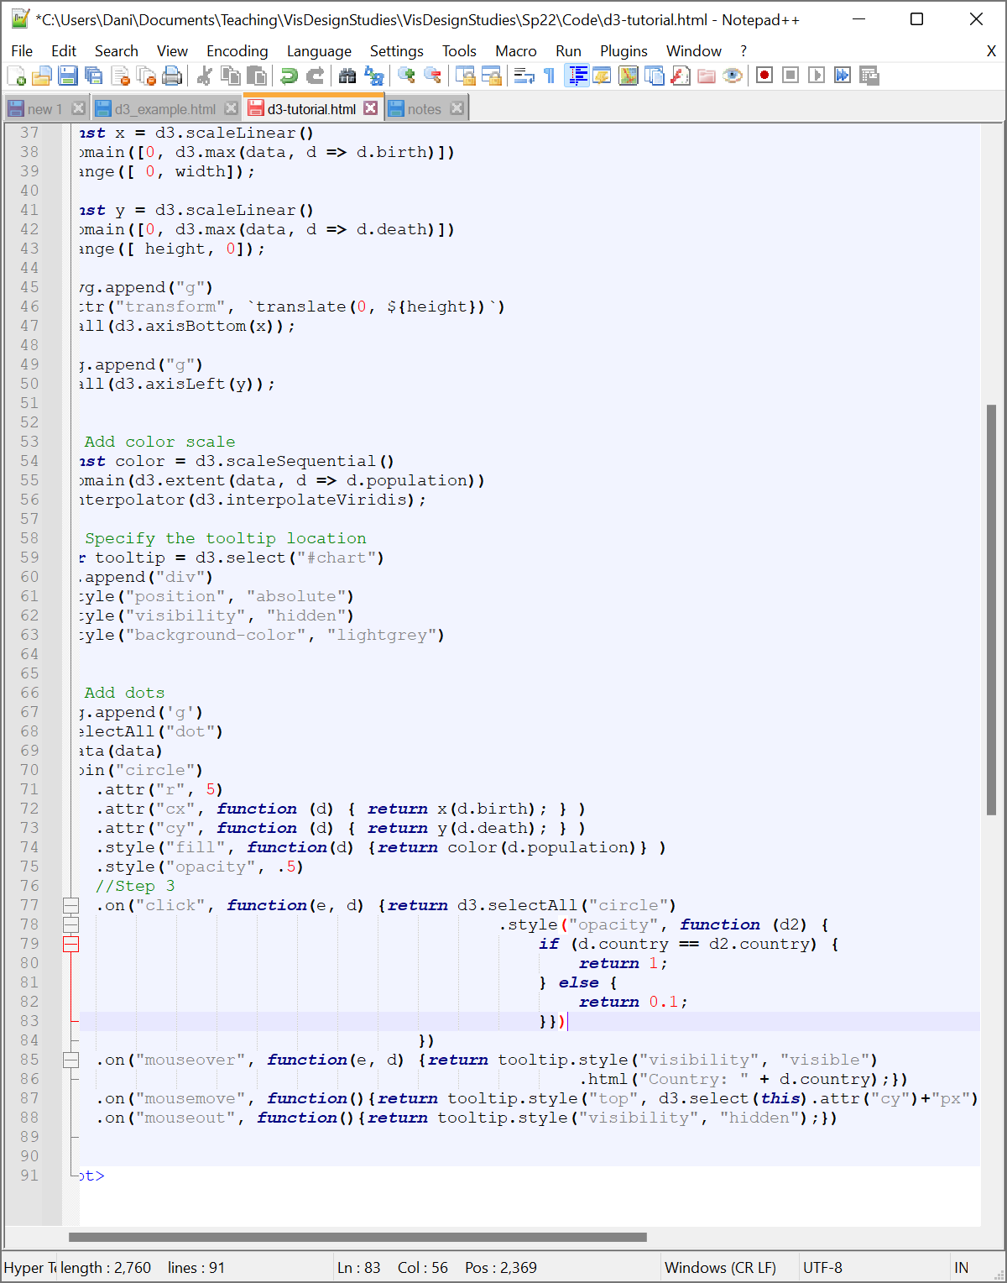

Once we’re on the mark, we can execute the mousemove event. This event will place the tooltip at the position of the mark we’re hovering over. We do this by first selecting the active point using the this keyword. Once we’ve picked this point, we can use the attr function with only one argument—the attribute we want to extract—to get the position of the mark we’ve moused over. We can bind the top and left of the tooltip to the position of the mark to place the tooltip in the right spot. The code looks like:

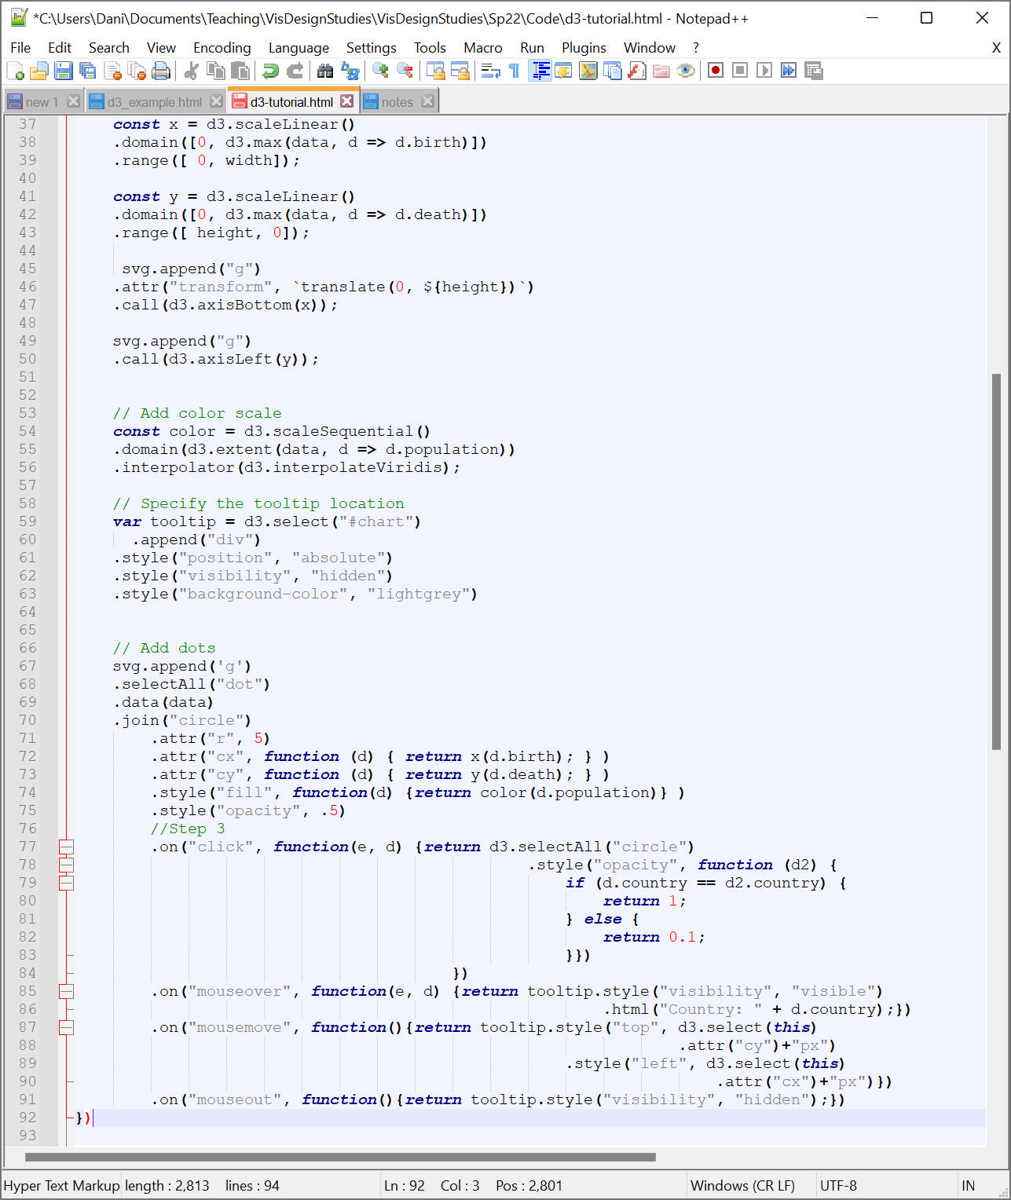

Note that we specify the “px” after the cx and cy call to deal with the fact that D3 will give us back strings in response to these calls. You could also simply cast the return values to numbers.

We can remove the tooltip when we mouseout by turning the visibility back to hidden when we mouseout. Note that we don’t have to move the tooltip since we’ll already be making it invisible.



**Part 8: Grouping Your Data**

In our current dataset, we see multiple values per country. Instead, we might want to look at one measure per country that represents a statistical perspective over the sampled points. That can help reduce the overdraw we see on the plot. There are a lot of different ways to group data ([this site](https://observablehq.com/@d3/d3-group) has a handy discussion), but we’ll just focus on taking an average for now.

Since we’ll go back to our unaggregated data later, create a copy of your current code and name it grouping.html. You’ll now want to make sure you visit localhost:8000/grouping.html to view your code.

While the current scatterplot shows us data for each country, we might instead care only about looking at the average value for each region of the world. D3 will let us do that without having to update our spreadsheet. To do so, we will use thedd

d3.rollup will group data together based on some specified attribute (in this case, we’ll group by country) and aggregate data across those groups (in this case, we’ll take the average birth and death values). It will give us a new dataset with a single datapoint for each of our country settings, creating a key-value pair, with country as our key returning a value object with properties birth and death. We will want to do this aggregation after we’ve loaded in the data but before we do anything with our data.

We’ll create a new variable called groupedData to hold our grouped data. Then, we’ll us our d3.rollup function to aggregate the data. Specifically, v will specify the computed values and d will specify the keys. Then, roll-up will create a map that creates a value for each key. We can specify these values are the average of a given property by using the d3.mean function. The last line just prints out your data to the console. The code looks like this:

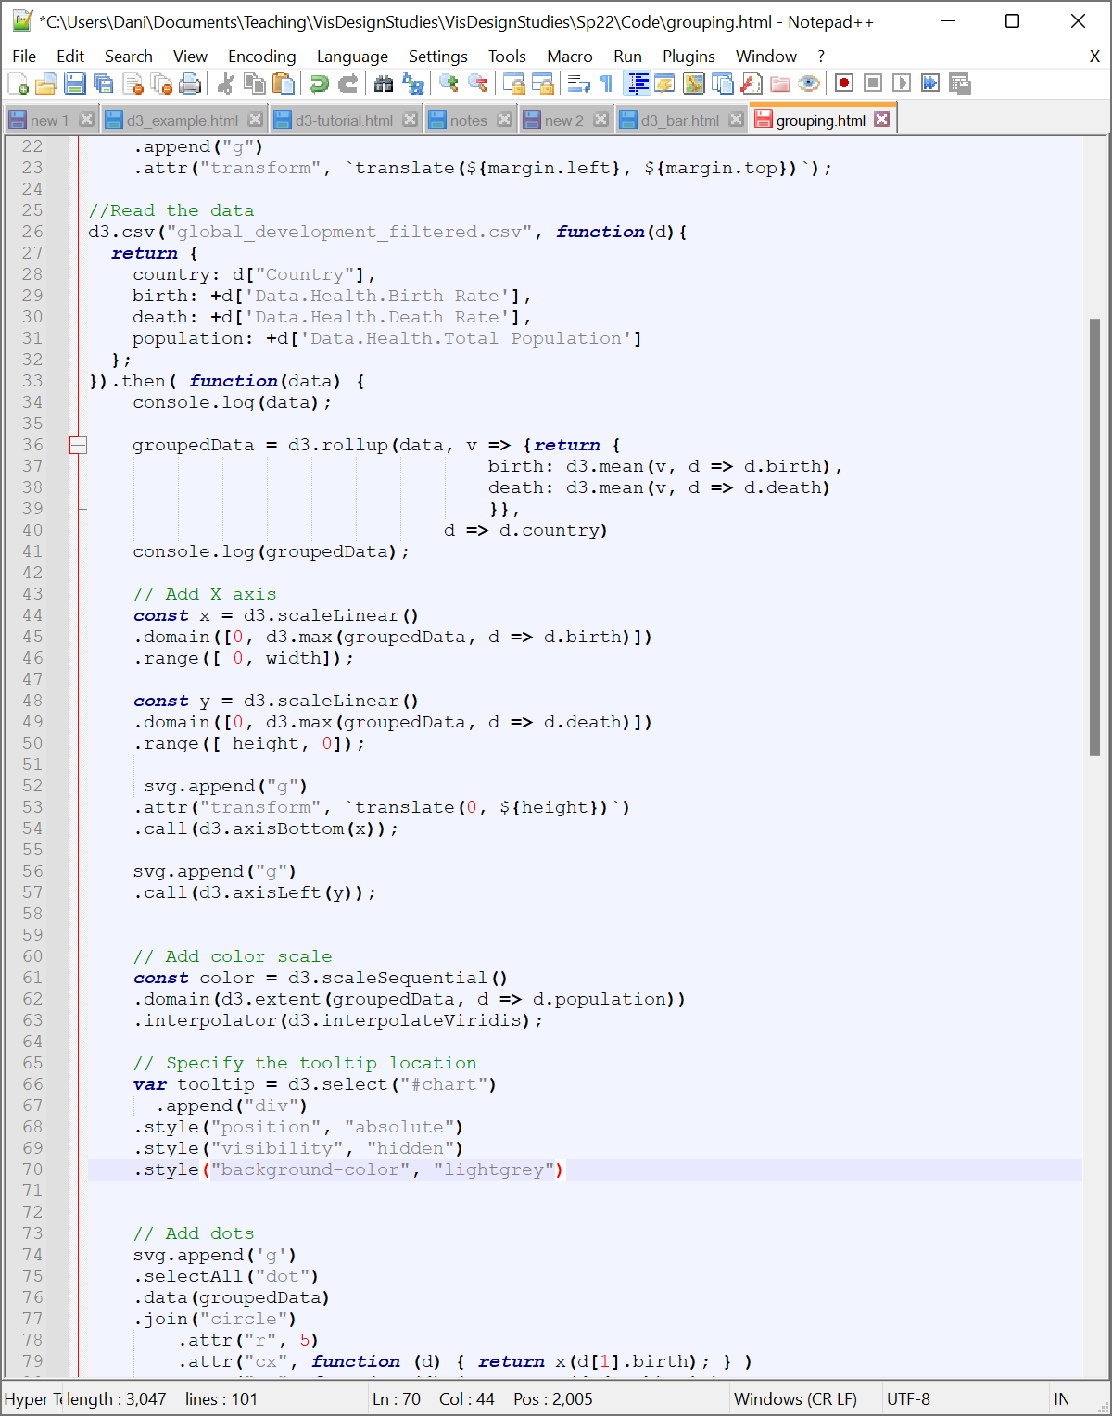

Note that you will either want to aggregate in ANY variables you want to use (e.g., population for color) or just remove those from your scatterplot code (e.g., change the fill to a fixed color) as the objects generated by the rollup will not contain any values that you do not specify here. In other words, the rest of the contents of data won’t be a part of groupedData. You can verify this by looking in your console:

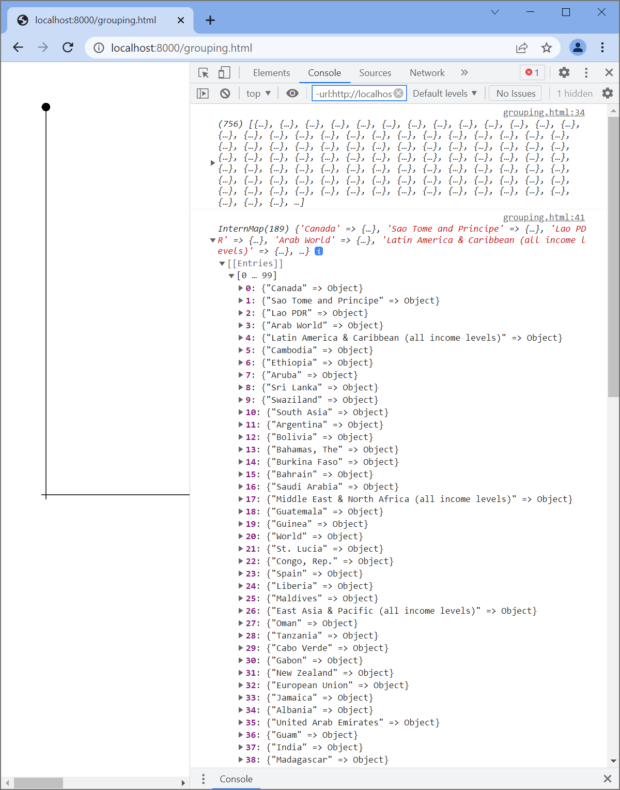

What this code does is create a new dataset with one datapoint per country. Each datapoint contains the country and the mean birth and death rates for that country. In this case, I’ve chosen to use these column names so we don’t have to change much in our code (e.g., d.birth will still return the birth rate), but you could change these names and add or remove columns depending on what you want to compute about your data.

Now that we have our aggregated data, we need to update our code to use this new groupedData. **Starting from the lines you’ve just added** (nothing sooner or your code will break), you’ll need to look for two things: any use of the variable data and any time you use a datapoint (in this case, d.country, d.birth, or d.death). Here’s how:

* **Fixing data:** This one is simple---we now want to use our groupedData instead of data. Replace all instances of data that occur after we’ve defined groupedData with groupedData.
* **Fixing d:** Notice when you printed out groupedData that it now has a key to value mapping instead of simply a set of properties. Our data is hiding in the values and we need to figure out how to get to it. Turns out, it’s pretty straightforward: find any instances where you reference a datapoint for a value other than it’s country (in other words, look inside all of your function(d) calls) and add “[1]” after d. This will fetch the value set for your datapoint. For example, function(d) {return d.birth;} becomes function(d) {return **d[1]**.birth;}). Note that you shouldn’t change the function(d) calls inside rollup. Country can now be accessed using d[0].

**Test Your Knowledge: Change your visualization to use your aggregated data.**

Your resulting visualization should have one point per region and look like this:

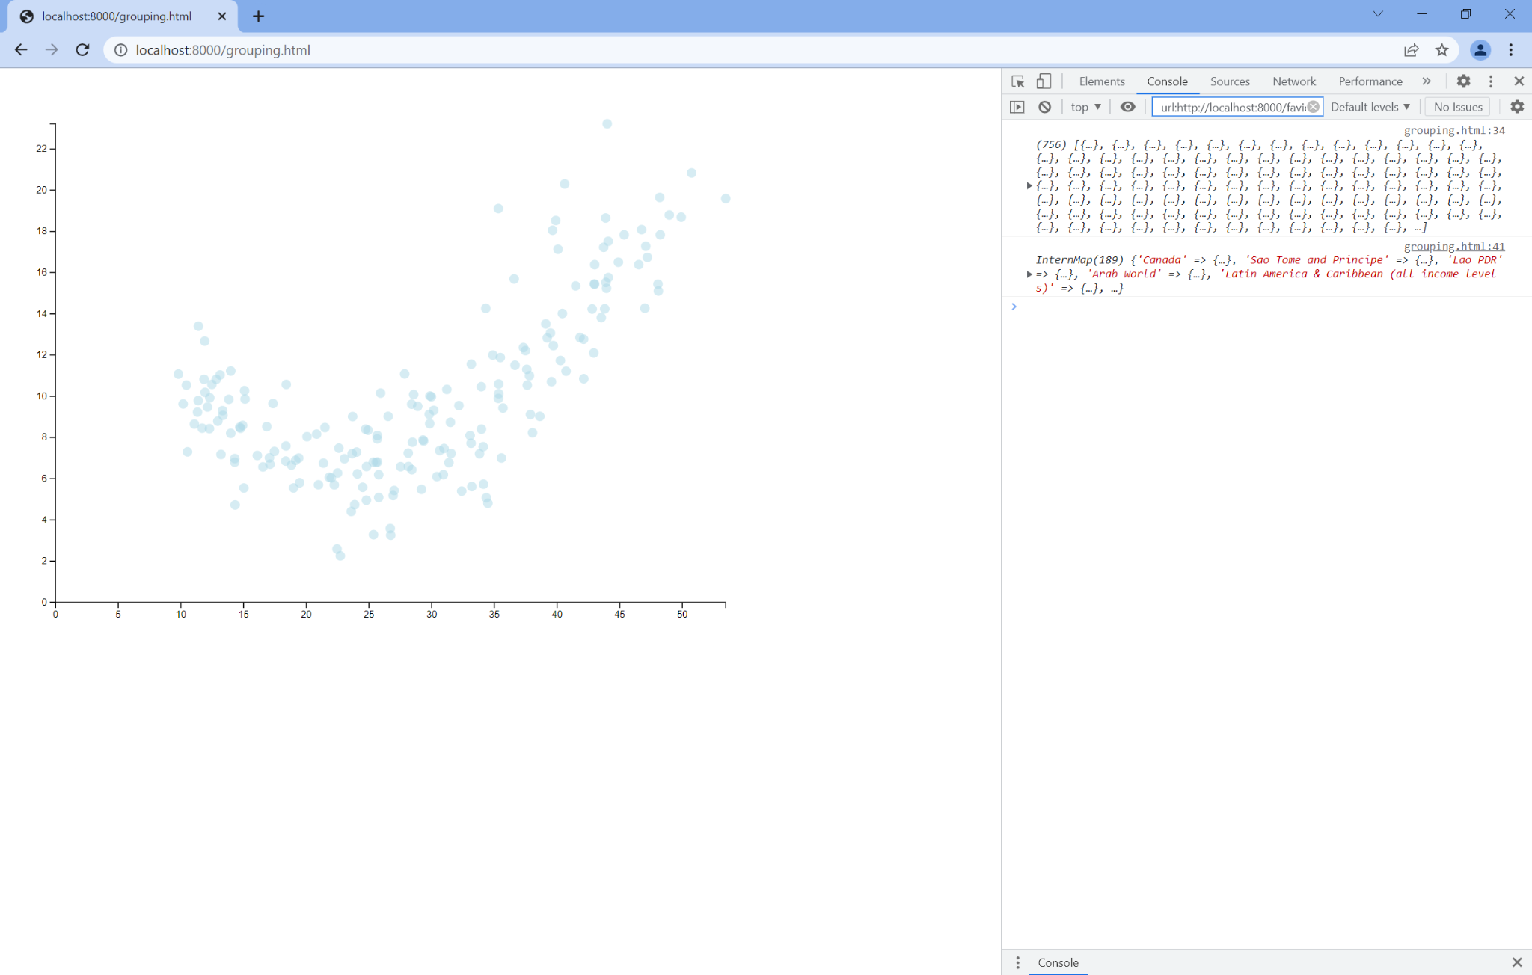

**Part 9: Building a Bar Chart**

One of the primary reasons to use grouping is to create a different kind of visualization, like a bar chart. We can do this by replacing all of our circle elements with rect elements whose height corresponds to some mean value (in this case, we’ll use the mean birth rate). Start by creating a copy of your grouping.html and naming it barchart.html. You can go to the new URL in your browser.

Now that we have a scatterplot, building a bar chart is a matter of two steps:

1. Updating the x-scale to use a categorical variabled
2. Updating marks to rectangles of appropriate height

We’re going to complete these steps one at a time.

To start, let’s update what data attributes we want to use. Let’s map birth rate to the y-axis and the country to the x-axis. For the x-axis, we’ll replace our linear scale with what is called a band scale. A band scale will essentially create one bin for each element in an array that we pass to the scale function. In this case, the array will be the set of country names. We can use the scaleBand function to set up a band scale and grab the keys of our groupedData map to get the sets of categories (note that you’ll want to instead use the map function if you’re working with unaggregated data). One last piece: since we’re dealing with categorical data, we don’t necessarily have a meaningful “spacing” along the x-axis. We can provide the distance between categories using the padding function, which will ensure a relative amount of spacing between our bars. The code ends up looking like this:

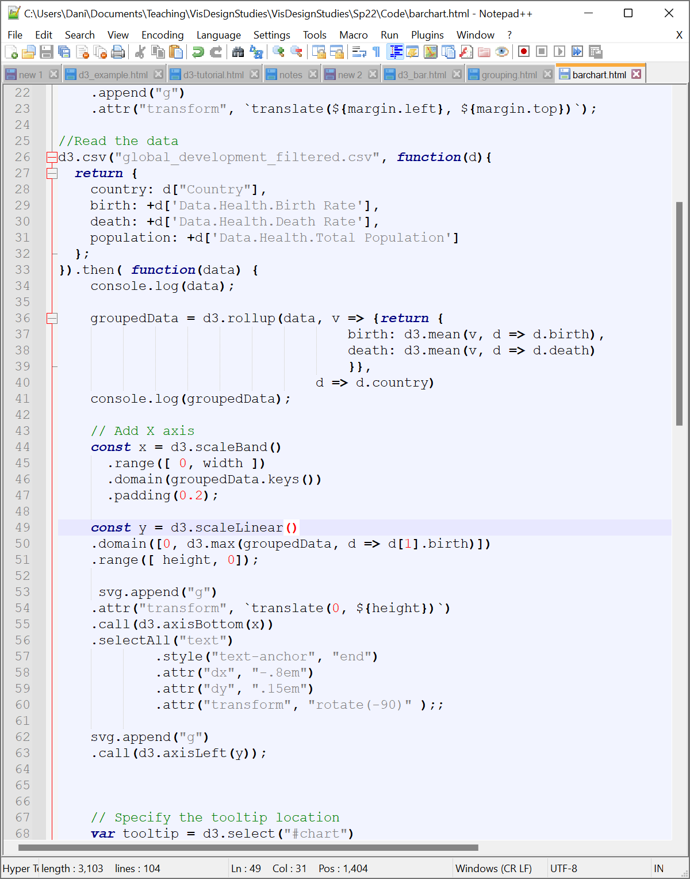

**Test Your Knowledge: Change your y-axis to use the average birth rate.**

We now want to adjust our SVG marks. Since we’re building a bar chart, there’s a few things we’ll want to do here:

1. Change our join function to use rectangular marks (rect).
2. Change our attributes from those used for circles (r, cx, cy) to those used for bars (x, y, width, height)

To start, we can simply replace the string to our join function to pass it “rect” instead of “circle”, which changes the kind of SVG elements we’re working with. Then, we need to update our attributes. For x and y, we can simply use our existing scales and make sure they point to the right data.

**Test Your Knowledge: Change your join and cx and cy attribute functions to instead set x and y. Make sure x maps each datapoint’s country and y its birth rate.**



Once you’ve updated your x and y, we’ll need to set our height and width. We can set the width of a mark using the band scale’s bandwidth function, which will return a precomputed width based on our graph size, number of points, and padding. For the height of the bar, things get just a little strange: because the origin is in the upper left, we can’t just use the position on the y-axis like we did with scatterplots. The inverted origin would invert the height of our bars as our y-coordinate specifies the top of the bar in the current code (if you just update the scatterplot code to take the birth rate variable). Instead, the height is going to be equal to the difference between the y-position and the bottom of the graph. In other words, height - y-position. The code looks like this:

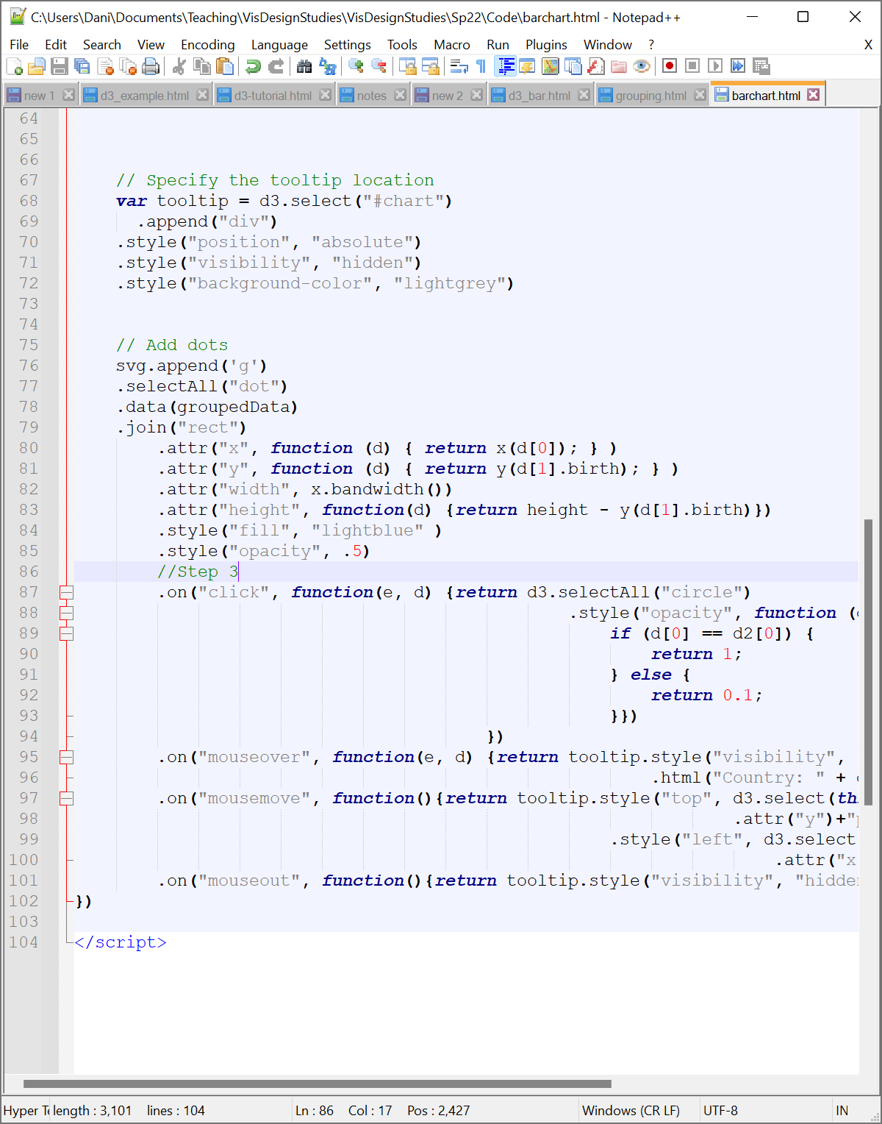

**Test Your Knowledge: Change your tooltips to use the x and y coordinates of your marks rather than cx and cy. Time permitting, experiment with other ways of getting relevant x and y coordinates, such as the mouse x and y using d3.mouse(this) to get the mouse position.**

If you have time, challenge yourself to experiment with changing the axis labeling to fit all of the names. Two things you may need to do:

1. Rotate the labels to a vertical alignment
2. Adjust the width and margins to give yourself a bit more canvas to work with

I’ll let you play with #2 on your own, but to achieve #1, you’ll need to rotate your text labels. We’ll do this by first selecting the text in our x-axis group right after we add the axis to our SVG (in other words, right after our call function) and then adjusting the position and rotation of the text. We can anchor the text by the end of the string (essentially a “right align” in traditional text editing) by specifying the text-anchor in the CSS style. We can then shift the text position slightly using dx and dy to make sure the labels line up with the appropriate axis positions. Finally, we rotate the labels using the rotate transform, passing it the angle of rotation (in this case, -90 degrees to get totally vertical labels). The code for adding our axis now looks like this:

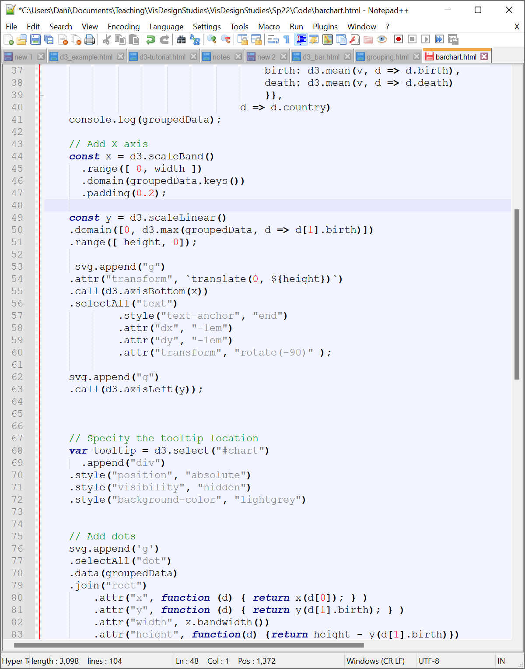

**Test Your Knowledge: Adjust the canvas dimensions to try to make the labels a bit easier to read. Post a screenshot of your bar chart to the slide deck.**

**Part 10: Building a Line Graph**

Next, we’ll explore how to build a line graph. To do this, we’ll take our grouped scatterplot, parse the year column from our dataset (specified by Year), and adjust the rollup function to compute the average value per year. We’ll then draw a line between each of these values in our graph.

**Test Your Knowledge: Create a copy of grouping.html and rename it linegraph.html. Go to localhost:8000/linegraph.html in a new tab. Now, in your data parsing code, add a line to grab the year as a numeric value.**

The first thing we want to do once we’ve updated our data is to adjust our rollup function. In this case, we’ll only need to shift our keys: we’ll want to average by year rather than by country.

**Test Your Knowledge: Change your rollup function to average values by year. At this point, your graph should look something like the graph below.**

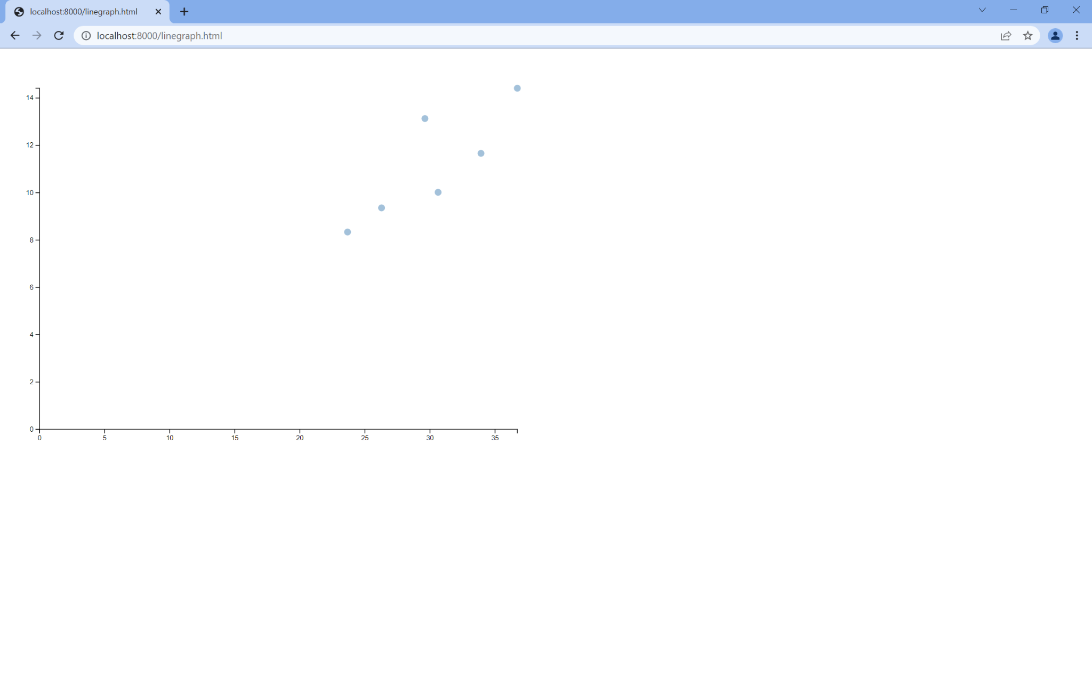

We can now update our graphs to plot the birth rate on the y-axis and the year on the x-axis. This requires three steps: updating our x-scale to work with the extent (rather than 0-max) of the year, updating the y-scale to work with the birth rate, and updating cx and cy to use the right data.

**Test Your Knowledge: Update your scatterplot to plot the year on the x-axis and birth rate on the y-axis. Hint: the year is now the keys in your groupedData map. Your scatterplot should look something like this:**

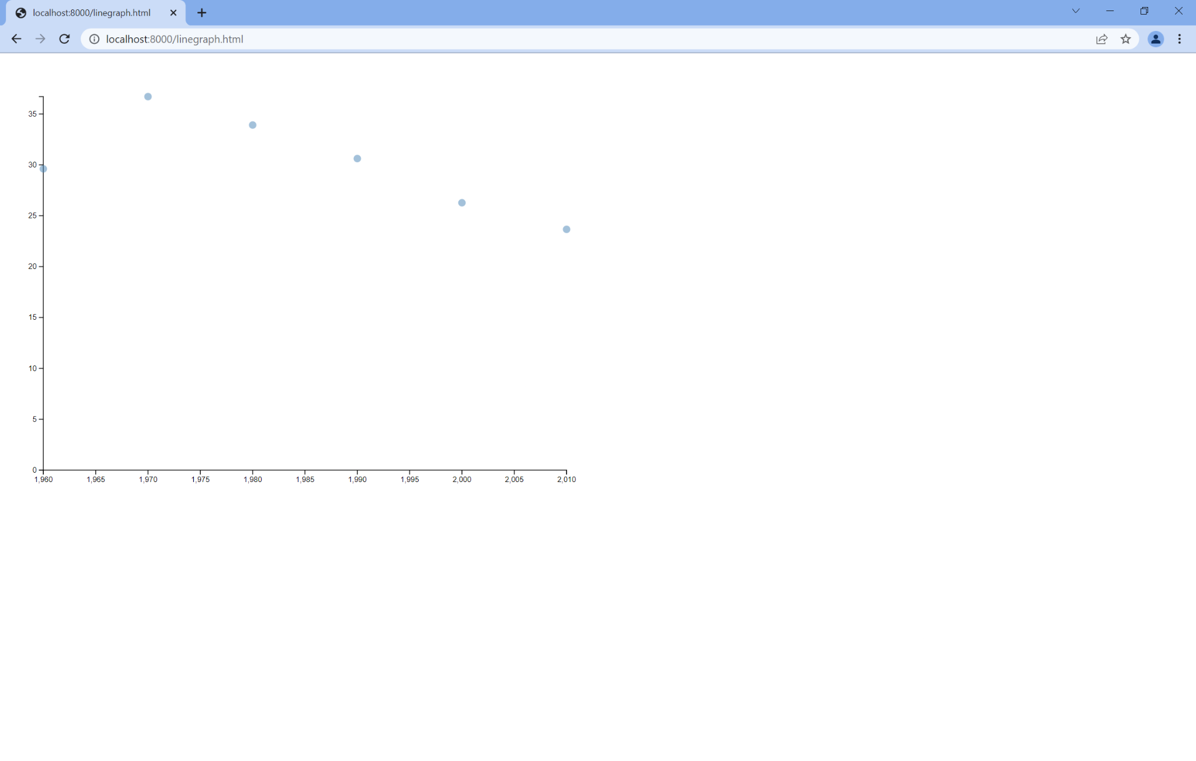

With scatterplots and bar charts, we draw one mark per datapoint. However, with line graphs, we draw marks *between* each datapoint. In order to do this, d3 offers us the ability to use path objects through the d3.line function. What d3.line does is essentially give us an easy way to shape an SVG path element, which will become the line in our line graph. Think of path as something akin to a circle or rect, we know how to draw it if we give it the right set of attributes: line will create those attributes for each datapoint.

We can specify our line by telling it how to pick an x and y coordinate for each datapoint. In your code, create your line after you’ve specified all of the pieces that you need to compute your x and y coordinates (in other words, right after you set your scales). The code looks something like:

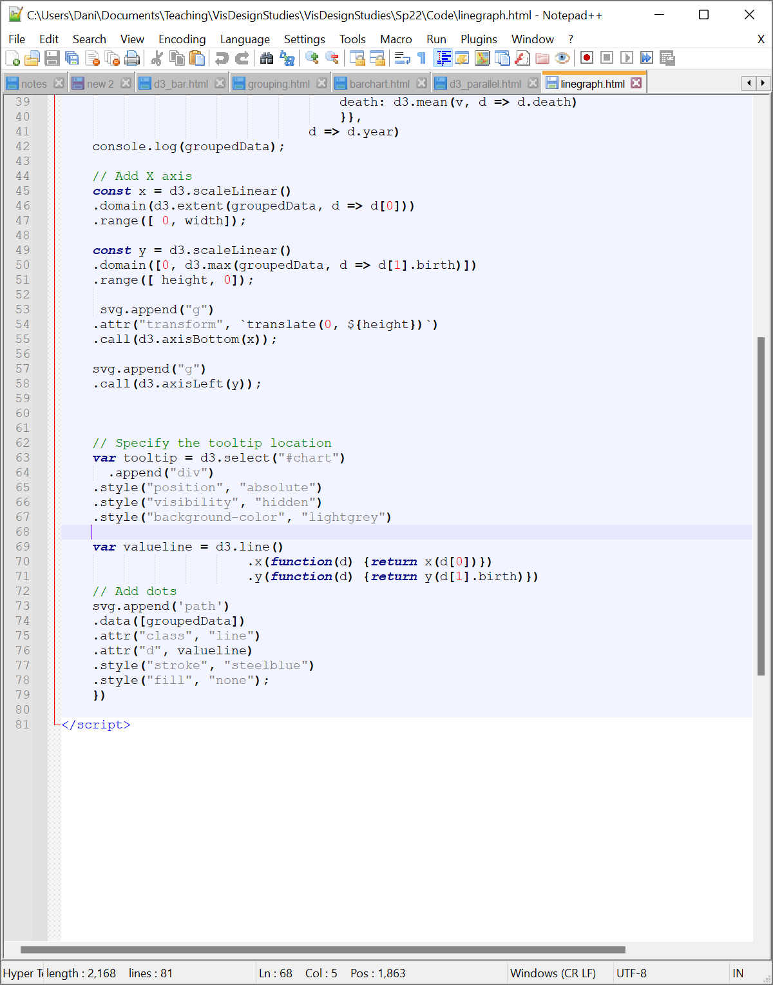

Once we have our code in place to be able to compute our lines, we can add our path elements to the SVG. This is where we’ll make some pretty drastic changes: we no longer want to specify individual points, but instead want to create a path that traverses all of our values.

Paths work a bit differently from rect and circle elements, so we’ll start by removing **all** of the code associated with our marks. From there, we’ll add a single path element to our SVG. You then want to pass your data as an *array* rather than as the raw data. Doing this is pretty simple: you just enclose your groupedData variable in square brackets. Once that’s in place, make sure your path has the class line that you’ve specified in your CSS and set the path’s attribute d (which specifies the coordinates you want your path to follow) to the line object. You can style things like the stroke color or the fill (by default it will be black, which will yield a strange-looking line graph, so setting it to none is usually advisable). The code looks like:

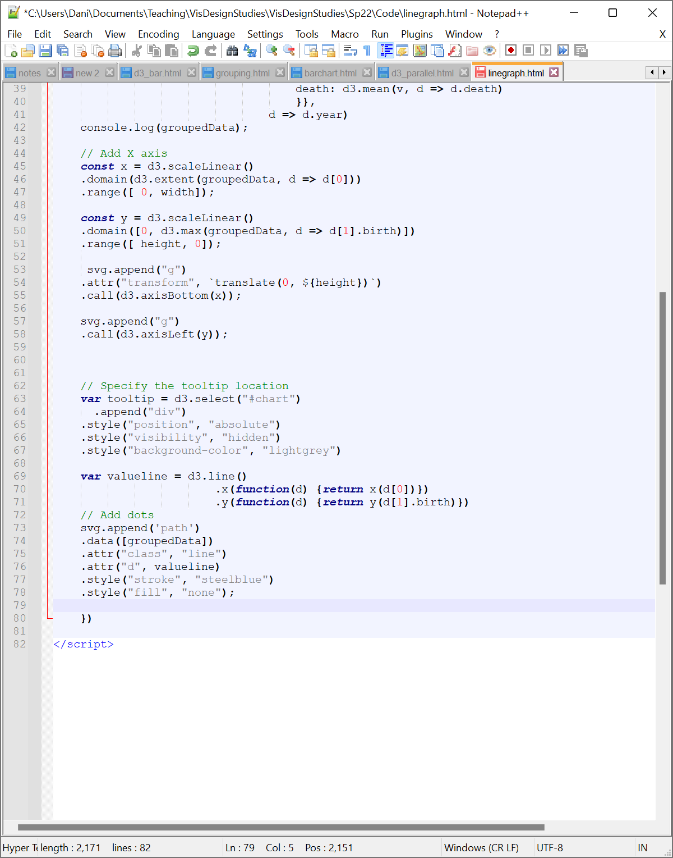

Once you’ve done this, your visualization should look like this:

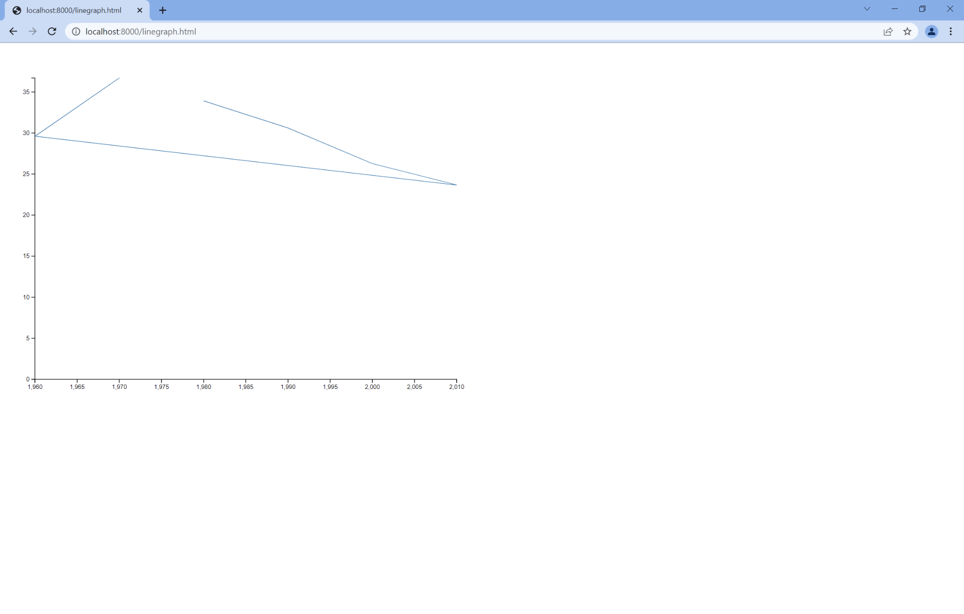

You’ll probably notice that this doesn’t quite look like a normal line graph. This is because D3 draws out the path in the order that the data appears in the data structure (in this case, the order of items in groupedData). We can adjust this by simply sorting our data based on the year. To do this, we’ll first cast our rollup from a map to an array and then use D3’s sorting functions to sort our data by year. The way we’ll do this is to first shift our aggregation to return an array. We do this by simply changing the function rollup to rollups (literally just add an s :-)). We can then append the sort function to the end of the rollups function to specify that we want to sort on the first element (in this case, our key value year) and that we want to sort in ascending order. The code looks like:

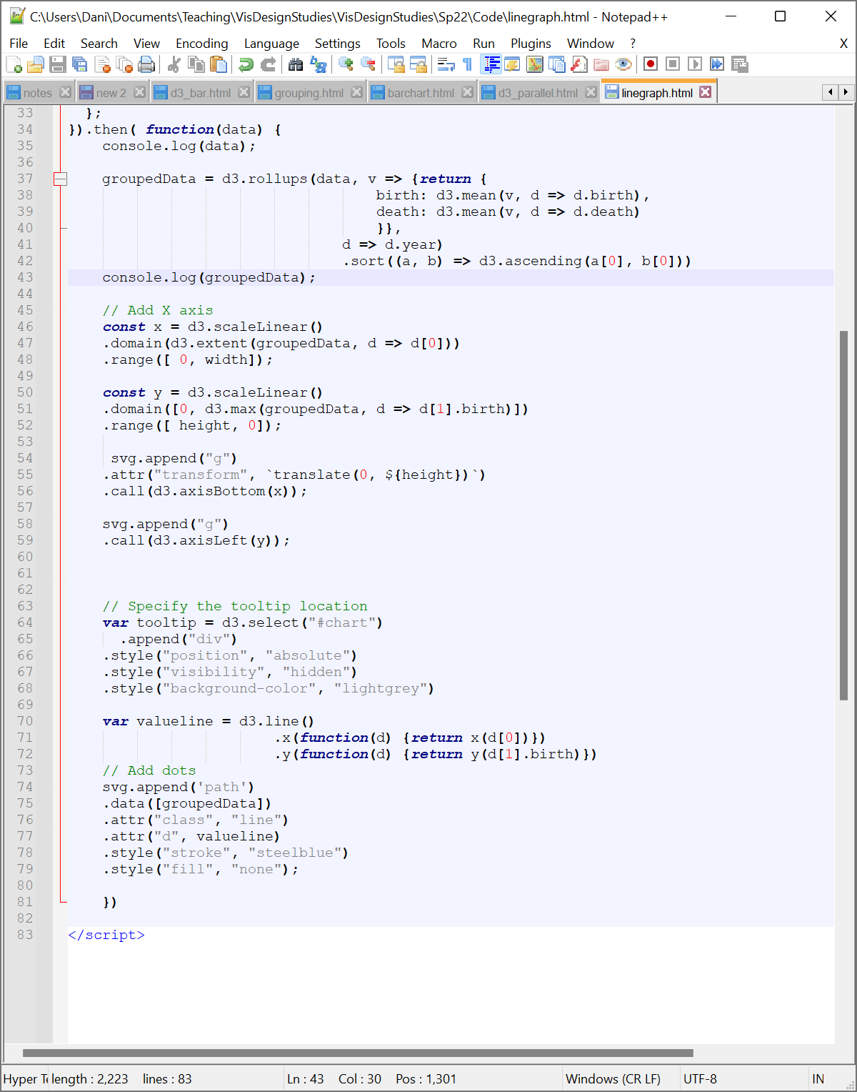

One thing to note here: the axis of your new graph has the years formatted as numerical values (the commas might be a bit counterintuitive). To fix this, we can treat Year as a time rather than just a number. Times get special treatment in Javascript, so we’ll need to update our parsing code to take in Year as a time object consisting of a single 4-digit year. We do this by passing the d3.timeParse function the string “%Y”, which signals we want to treat the ensuing value as a 4-digit year (e.g., 1960).

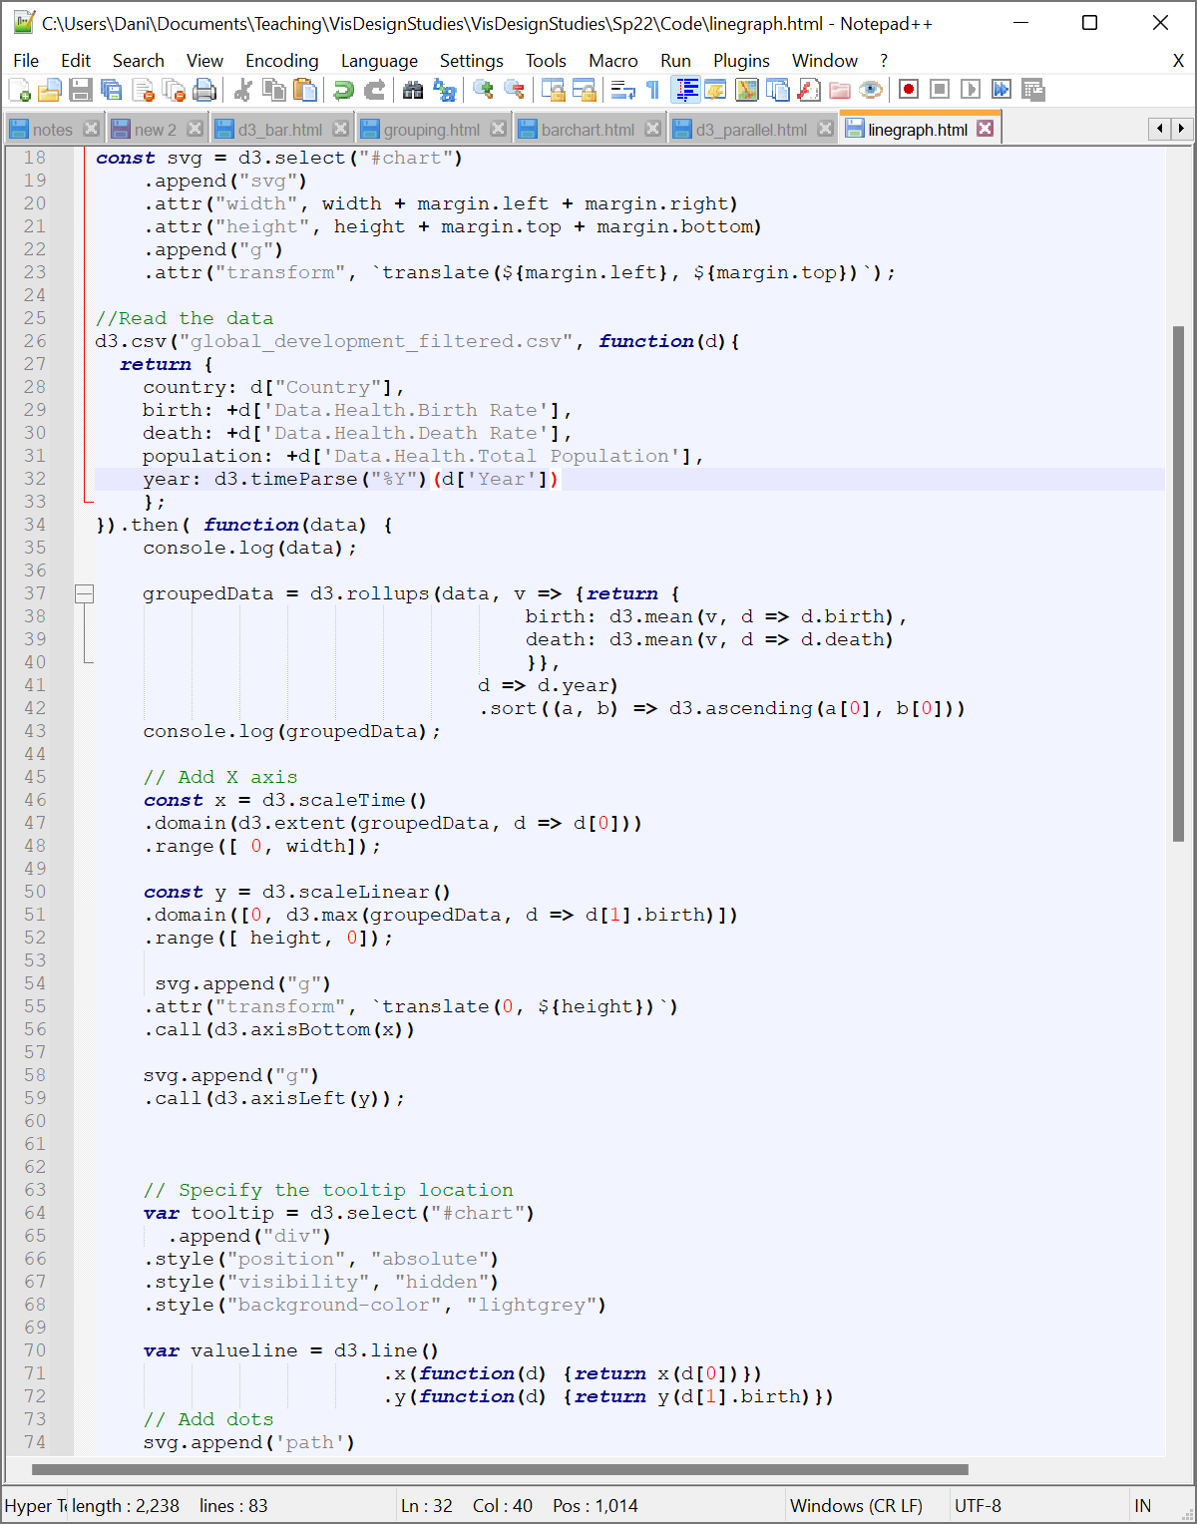

Now, just change your x scale from scaleLinear to scaleTime and you should have something that looks a little more reasonable on your x-axis.

**Test Your Knowledge: Upload a screenshot of your line graph to the slide deck.**

**Part 11: Building a Multiline Graph**

We can drill down a little deeper into our data to look at change over time by country. We’ll first separate out our data out by country using D3’s group function. For the group function, we just need to pass in our dataset (we’ll go back to the original data this time) and a function mapping out the data we want to group on. The function will return an array of grouped data. This will give us an array with one subarray for each country. The first element of each subarray is the country and the second is a subarray of datapoints associated with that country (one per year in this case). The code looks like (in place of the old rollup function):

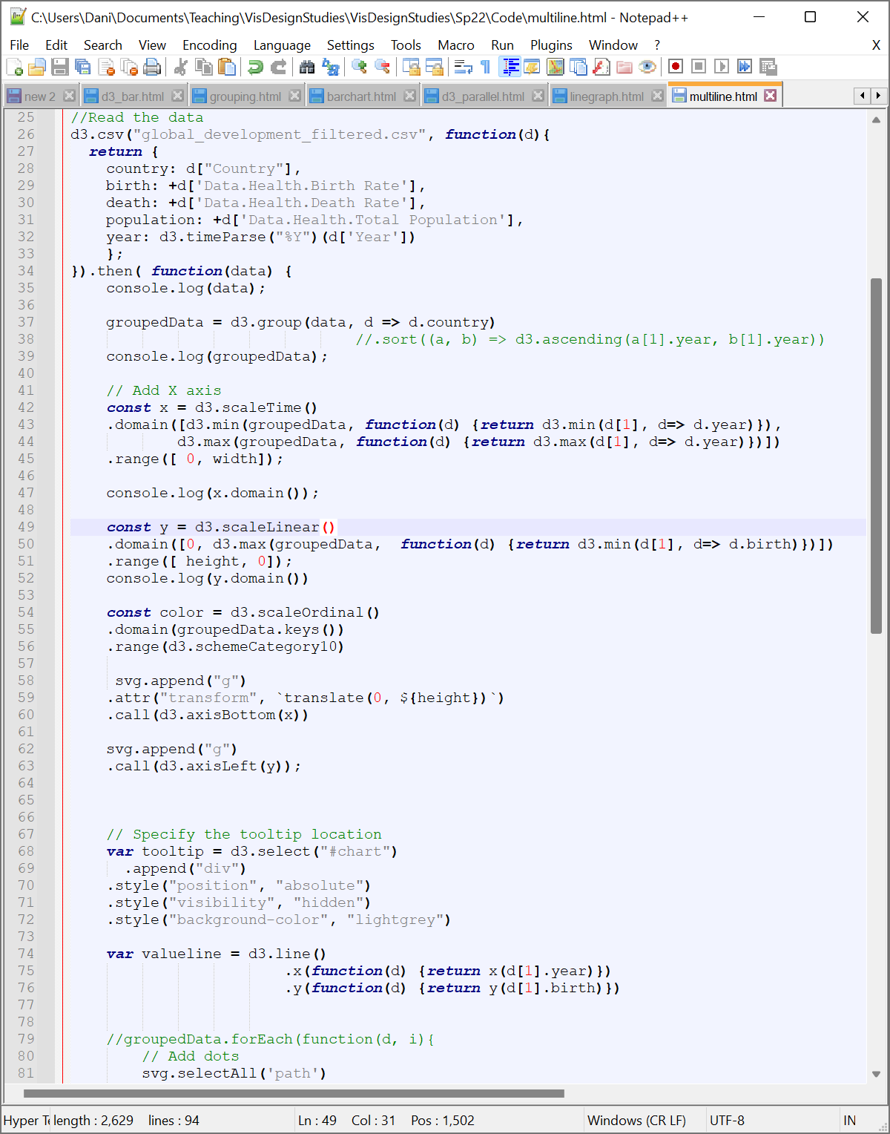

Since our grouped data structure has changed, we’ll need to do some adjustments to get our scales working correctly. In particular, we now have our data nested inside of our key-value pairs in our grouped tables. We specifically will want to find the minimum value of all minimums and the maximum value of all maximums for our x-axis and just the max of maxes in our y-axis. To do that, we’ll just use some nested min and max calls. Keep in mind that our data is going to have one entry per country and then our data at position 1 (the value) is going to have four entries—one per year. To unpack these, replace your x scale code with this:

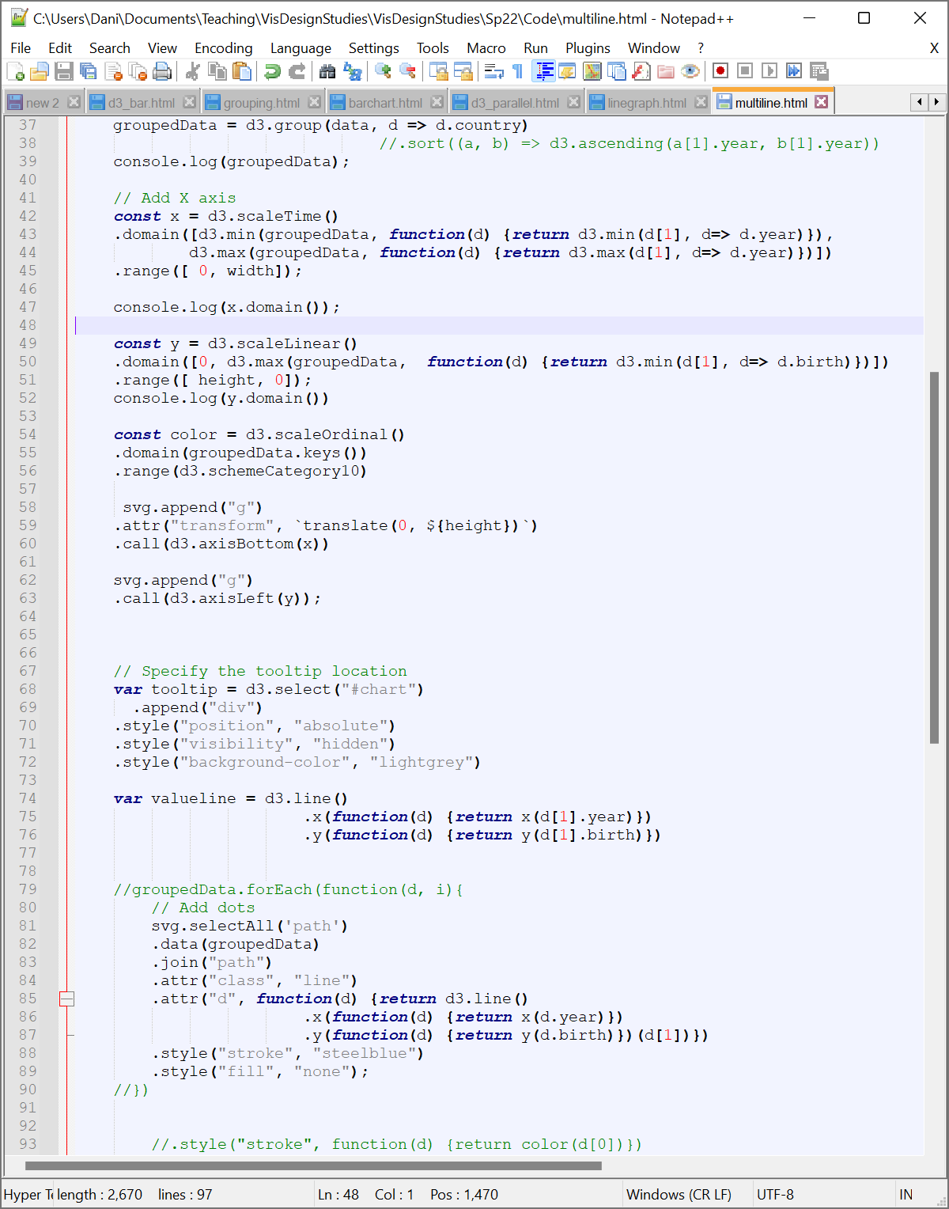

**Test Your Knowledge: Update your y axis domain to reflect the new grouped structure.**

Since we now have our axes updated, we’ll need to create our path objects. We’ll shift back to a selectAll/data/join structure as in our earlier graphs such that we create a new path for each of the entries in our grouped dataset. To do this, we’ll want to start by selecting all of our path objects, passing in our standard grouped data (no need to have it be a list this time), and joining everything on a path. The code looks like this:

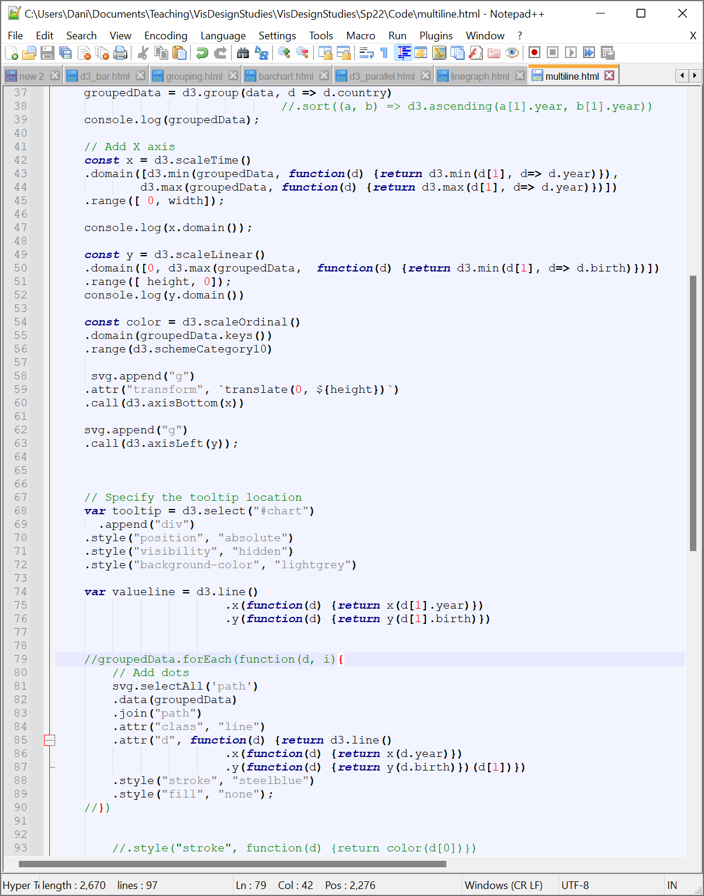

Now, to specify the data d for each path, we’ll need to pass the relevant information to our function: namely, the properties of d we want to use as well as the overall data array associated with d (d[1] in this case since we want to grab our values). We can manipulate our valueline function to do this, but for the sake of simplicity, let’s just move the function call to an inline function. We’ll specify the function and then pass the d[1] object to the function call. We can keep the rest of our styling the same. The code looks like this:



If you run this, you’ll get a mess of lines (some that traverse all of the time points, some only post-1980). We might want to use color to help distinguish different lines. There’s no great solution that will give us recognizable colors for this many points, but we can use D3’s scaleOrdinal to map each datapoint to a color to improve our abilities to distinguish local groups. D3 offers a range of colormappings. For this example, we’ll use d3.schemeCategory10, which offers 10 distinct colors. Once D3 uses these colors, it will repeat colors again until each datapoint has a color assignment. We can do this assignment using a scaleOrdinal and giving it the domain of all possible country values (groupedData.keys()) and a range of colors (d3.schemeCategory10). The scale looks like:



**Test Your Knowledge: Update your stroke styling to use the new colors. Hint: to access the country name, you’ll want to use d[0].**

Now you should have a line graph with different colored lines for each value. It’s a bit of a mess (one might call it a spaghetti plot), but all of the data is there. A quick challenge for you to be able to make more sense of this data:

**Test Your Knowledge: Add tooltips to your line graph to show the country names. Once you’ve completed the graph, add a screenshot to the slidedeck.**

**Part 12: Building a Parallel Coordinates Plot**

A parallel coordinates plot also uses path marks to encode data. However, the name *parallel coordinates* stems from the idea that you’re mapping that data across multiple axes arrayed in parallel. To encode a data point, you draw a line between its value on one axis and its value on the adjacent axis. This is a common technique for working with higher dimensional data as it lets you explore correlations across moderate numbers of dimensions.

Rather than walk you through the mechanics of parallel coordinates in D3, I’ve provided code developed for a different dataset [here](https://drive.google.com/file/d/1o9da2X9ktnTJwNCeV_zJ3H4WWBdQR-GG/view?usp=sharing) with comments that explain briefly what each chunk of code does. Note that here I’ve used bracket notation rather than dot notation to access the properties of a datapoint. For this data, it’s important to note that:

d[name] == d.name

This makes it easier to iterate over a list of dimensions, which saves us a lot of headache in building higher dimensional visualizations like parallel coordinates.

**Test Your Knowledge: Download** [**d3_parallel.html**](https://drive.google.com/file/d/1o9da2X9ktnTJwNCeV_zJ3H4WWBdQR-GG/view?usp=sharing)**. Update the code here to use the global development measures dataset, choosing a few columns out of the data you’re interested in exploring. Post a picture of your visualization to the slide deck.**

**References:**

Below are the sources I used as guides for the examples above. Check them out to learn more!

D3 V6 Tutorial: <https://www.dashingd3js.com/d3-tutorial>

Manipulating Colors: <https://www.d3-graph-gallery.com/graph/custom_color.html>

Tooltips: <http://bl.ocks.org/williaster/af5b855651ffe29bdca1>

Summarizing Data: <http://learnjsdata.com/summarize_data.html>

Grouping Data: <http://learnjsdata.com/group_data.html>

Bar Charts: <https://bl.ocks.org/d3noob/bdf28027e0ce70bd132edc64f1dd7ea4>

Line Graphs: <https://bl.ocks.org/d3noob/402dd382a51a4f6eea487f9a35566de0>

Multiline Graphs: <https://bl.ocks.org/d3noob/f8b7f107ba25c21971851728520224cb>